

A Sample Engagement Process for Implementing a Web Site

Definition Stage

Table of Contents
Business and Creative Workstream Overview 5
Content Workstream Overview 6
Organizational Readiness Workstream Overview 7
Technology Workstream Overview 8
Testing Workstream Overview 9
Definition Stage 10
Business and Creative Work Product Flow 12
User Types and Needs 13
Overview 13
Work Product Template 14
Sample Work Product 15
Customer Segmentation Strategy 19
Overview 19
Work Product Template 20
Sample Work Product 21
Requirements Matrix 22
Overview 22
Work Product Template 23
Sample Work Product 24
High Level Use Case List 28
Overview 28
Work Product Template 29
Sample Work Product 30
Detailed Use Cases 33
Overview 33
Work Product Template 35
Sample Work Product 37
Preliminary Site Map 43
Overview 43
Sample Work Product 44
Functional Storyboards 45
Overview 45
Sample Work Product 46
Relationship Architecture 47
Overview 47
Work Product Template 49
Sample Work Product 50
Business Rules Catalog 51
Overview 51
Work Product Template 52
Sample Work Product 53
ERM Classifiers and Qualifiers, Programs and Channels 54
Overview 54
Work Product Template 55
Sample Work Product 56
Content Work Product Flow 57
Content Inventory, User Content Needs and Gap Analysis 58
Overview 58
Work Product Template 59
Sample Work Products 60
Content Migration Issues 69
Overview 69
Work Product Template 70
Sample Work Product 71
Content Categories and Subcategories 76
Overview 76
Work Product Template 77
Sample Work Product 78
Content Attributes 82
Overview 82
Work Product Template 83
Sample Work Product 84
Authors, Roles and Workflow 85
Overview 85
Work Product Template 86
Sample Work Product 87
Publishing Requirements 88
Overview 88
Work Product Template 89
Sample Work Product 90
Organizational Readiness Work Product Flow 93
Current Organizational Structure 94
Overview 94
Work Product Template 95
Sample Work Product 96
Current Organizational Skills 97
Overview 97
Work Product Template 98
Sample Work Product 99
Organizational Readiness Training Needs 100
Overview 100
Work Product Template 101
Sample Work Product 102
Organization Needs 103
Overview 103
Work Product Template 104
Sample Work Product 105
Technology Work Product Flow 106
Technical Architecture Overview 107
Review Business Objectives and Priorities Document 108
Review BroadVision "Out of the Box" Functionality 109
Determine Technical Architecture Limitations within Release Timeframes 112
Create Release Functionality Matrix 114
Interface/Batch/Data Migration Architecture Overview 115
Review Back-End Systems 116
Define Interface Requirements between BroadVision and Back-End Systems 118
Define Data Mapping between BroadVision and Back-End Systems 120
Technical Infrastructure Overview 121
Review ‘as-is’ Technical Infrastructure 121
Determine Technical Infrastructure Requirements 123
Define Environment Strategy (Including Staging) 125
Define Configuration Management (Version Control, Build Procedures) 126
Define Technical Conventions and Standards (Naming Conventions, Standard Directory Structure, Coding Standards) 127
Define ‘to-be’ Technical Infrastructure 128
Order Required Hardware 130
Reporting Requirements Definition Overview 131
Report Design 132
Review Default BroadVision Reports 133
Perform Gap Analysis 134
Validate Reporting Requirements with Business Team 136
Search Requirements Definition Overview 137
Review, Develop Search Requirements 138
Review Base Verity Search Capabilities 140
Perform Gap Analysis 142
Define Search Strategy 144
Data Architecture Overview 146
Identify Data Sizing Estimates 147
Testing 150
Glossary 151

Business and Creative Workstream Overview
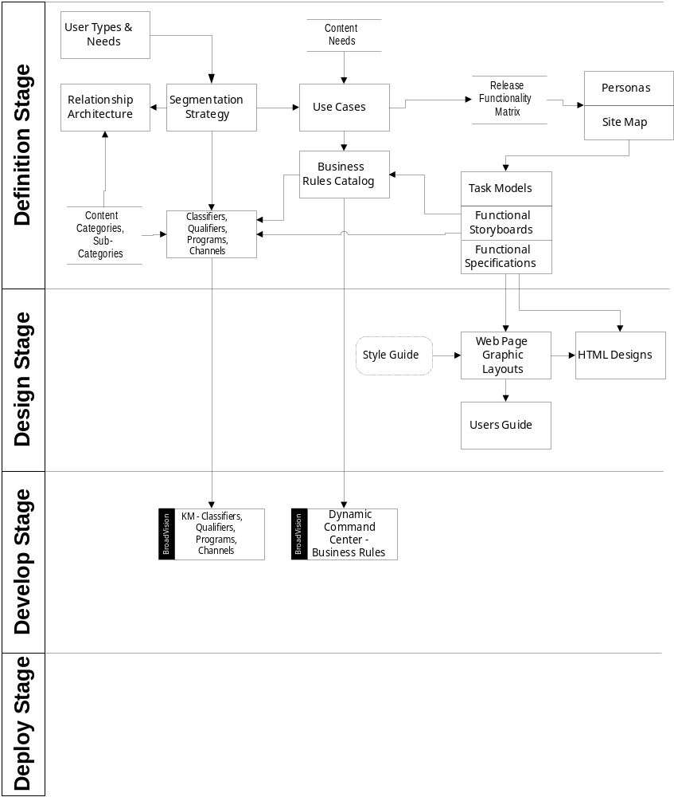

Content Workstream Overview
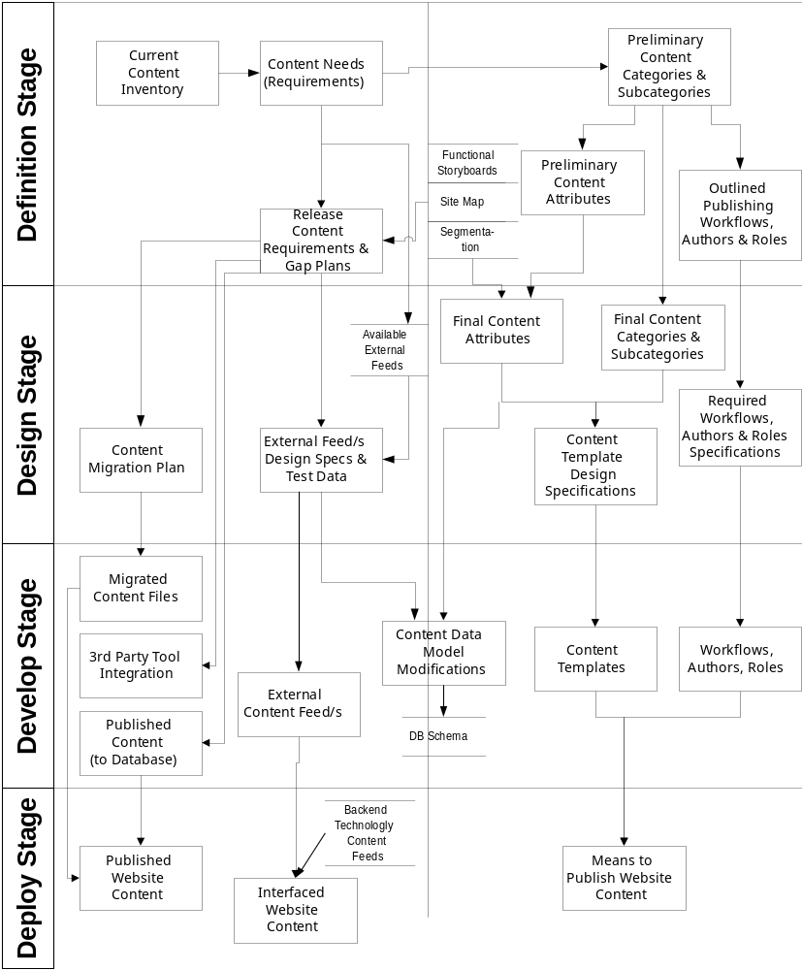

Organizational Readiness Workstream Overview
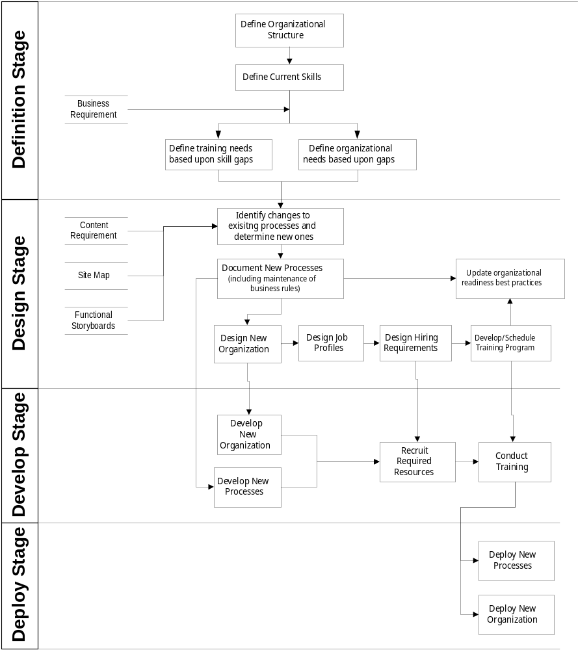

Technology Workstream Overview
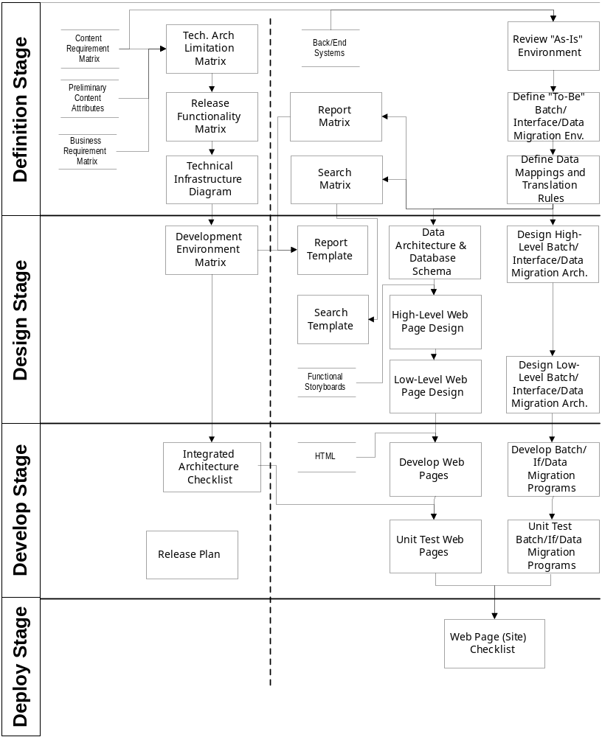

Testing Workstream Overview
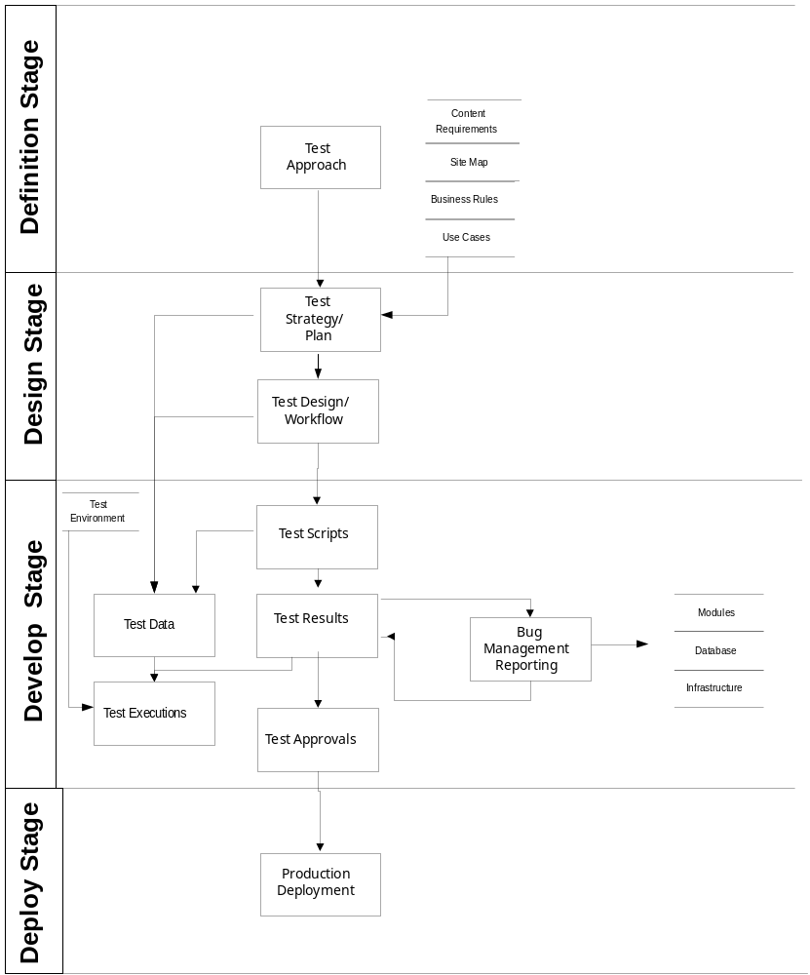

Definition Stage

1 - Business and Creative

A - User Types and Needs

B - Customer Segmentation

C - Requirements Matrix

D - High-Level Use Case List

E - Detailed Use Cases

F - Preliminary Site Map

G - Functional Storyboards

H - Relationship Architecture

I - Business Rules Catalog

J - ERM Classifiers and Qualifiers

2 - Content

A - Content Inventory, User Content Needs and Gap Analysis

B - Content Migration Issues

C - Content Categorization

D - Attributes

E - Authors, Roles and Workflow

F - Publishing Requirements

3 - Organizational Readiness

A - Current Organizational Structure

B - Current Skills

C - Training Needs

D - Organization Needs

4 - Technology

A - Technical Architecture

B - Interface-Batch-Date Migration

C - Technical Infrastructure

D - Reporting Requirements

E - Search Requirements

F - Data Architecture
5 - Testing
6 - Glossary

Business and Creative Work Product Flow
Set a business context
Define user types and user needs
Define segmentation strategy
Define high-level use case list
Define detailed use cases
Define conceptual architecture (including consolidation of use cases)
Define functional storyboard
Define relationship architecture
Define business rules
Define ERM classifiers and qualifiers
Define requirements matrix

User Types and Needs

Overview | The end user identification and needs analysis process is the foundation activity of the site/marketing strategy development and influences the entire scope of the project. This analysis is built into a matrix designed to identify required content, tools and functionality and categorize users(s). The refinement of the matrix is an iterative process that takes place during the definition phase. This matrix will also address high-level goals for personalization by identifying user activities. In addition, the matrix format will support a visual re-organization of user segments, as proxies for BroadVision Communities, once the marketing managers have completed the template.

Approach | Determine user types by identifying all potential users visiting the site. Once the user types have been outlined, we can then list high-level user wants and needs associated to each user type. Consolidate user types list by identifying the commonality (similar wants and needs). Determine the tasks that are necessary to fulfill associated wants and needs.

Work Product | The typical working document is prepared and managed in an MS Excel worksheet in a matrix form that provides for ease of manageability and organization. Typical matrix organization column header’s are: End User Type, End User Needs, and Required Functionality by phase / importance.

Work Product Template

User Types | User Wants / Needs

Sample Work Product
User | User Wants / Needs
Owners | I need FS product information
 | I need non-FS product information
 | I need FS advice
 | I need non-FS advice
 | I want to buy business services (Bank and other non-Bank services)
 | I need to manage my accounts (Bank and non-Bank) *
 | I need to network
 | I need to staff my business
 | I need a business plan / strategy
 | I need to sell products or services
 | I need industry and economic news and information
 | I need to achieve a balance in my life
 | I need to manage my daily business more efficiently
 | I need letters of credit
 | I need foreign currency services
 | I need marketing advice
 | I need payroll services
 | I want to maximize my business operation
 | I need advice /tools on managing my business efficiently
 | I want to do business in the New Economy
 | I need referrals for my business
 | I need to sell my products
 | I need tax advice
 | I need to procure items
 | I need to attract and retain employees
 | I need info about my current accounts
 | I need to know where the economy is going
 | I need to learn how to use the Internet to manage my business
 | I need retirement planning
 | I need succession planning
 | I need to network with other businesses
 | I need competitive/industry/customer information
 | I need financial planning advice (individual or business)
 | I need benefits management
 | I need capital financing
 | I need real estate services
 | I need legal advice
 | I need to have a life!
 | I need merchant services
 | I need to understand my responsibilities as an employer
 | I need infrastructure services…what do I buy?
 | I need cash management services
 | I need account servicing or customer service
Managers/ Admin | I need to perform a financial transaction *
 | I need help to do my job better
 | I need to manage my career
 | I need to buy stuff for the business
 | I need help getting organized
 | I need to keep track of events, tasks, etc.
 | I need to better manage tasks among my staff
 | I need to implement a business plan
 | I need assistance with human resource management
 | I need to market our stuff
 | I need to get the technology working
 | I need to organize and execute admin tasks
 | I need to network
 | I need to generate invoices and manage receivables
 | I need to set staff authorization levels
 | I need account servicing or customer service
Staff | I need to learn how to do my job better
 | I need to manage my career
 | I need to get organized
 | I need to review the company calendar and schedules
 | I need to find out my responsibilities
 | I need information about my company
 | I need to sign up for benefits and provide payroll information
 | I need to update our files/information
 | I need to help sell stuff
 | I need to manage my expenses
Third Parties | I want to refer a customer
(agents, referrers, suppliers) | I want to see the status of my referral (and know what I get for it)
 | I need info about Bank
 | I need to transact on behalf of my customer
 | I need to network
 | I need enroll in the referral program
 | I need education and info specific to my industry
 | I want information about customers Bank has referred to me
 | I want to know how to become a supplier to Bank customers
Aspiring Business Owner | I want financial advice on how to start a business
 | I want non-financial advice on how to start a business
 | I need resources to start my business
 | I want to know how to start a business
 | I want to know how to get funding
 | I want industry and economic research
 | I want to network and find partners
 | I want help writing a business plan
 | I need information on employee issues
 | I need a reality check -- what am I getting into?
Bank RMs | I need to see my customers' account information
(roughly 150 people) | I need to access profiles and settings for my customers
 | I need to communicate with my customers
Note: | I need to know what my customers are doing (reporting)
Need break out session w/ | I want to know who's registered (reporting)
RM stakeholders | I need to set alerts and notifications / customize experience
 | Participate in an online discussion or offer advice online
 | Find out which RMs have logged on (reporting)
Customers
Non-customers
Cardholders
Non-cardholders
Registered
Non-registered

Customer Segmentation Strategy

Overview | Typical customer segmentation strategies or community dimensions are a function of common user needs/attributes and internal marketing strategies. The above User Types & Needs Analysis and associated matrix template may serve as the primary input to this strategy.

Approach | Determine both the core and extended needs of the user. Make use of the client's marketing strategy to generate mutually exclusive, collectively exhaustive communities. Typically communities are based on one of the following:  - Customer value  - Role in Organization  - Industries  - Region  - Demographics  - Lifestage  - Psychographics  - Experience  .

Work Product | The deliverable is a consolidated statement of discreet high-level segments/ communities and sub-segments/sub-communities in MSWord format.

Work Product Template

TBD

Sample Work Product

TBD

Requirements Matrix

Overview | The requirements matrix captures and details all known system requirements. The matrix is composed of not only business/functional requirements, but also purely technical considerations. This is a document that maps business objectives and capabilities to the technology capabilities that are needed to fulfill these objectives. The types of information this document captures are intended as input to conversations related to scoping and release schedules. Many of the considerations are captured in the priorities and complexities of each of the system requirements.

Approach | The approach to completing the requirements matrix is to list all the capabilities required of the system in order to enable the fulfillment of the business strategy. These capabilities are initially identified through a review of the project business case or business strategy. Further refinement of the capabilities occurs during the discovery and definition phases through use cases, content inventory, and analysis of the selected technology capabilities. Input from all stakeholders (both business process and technical) is essential to complete the requirements matrix.  .

Work Product | The typical working documents are prepared and managed in an MS Excel worksheet in a matrix form that provides for ease of manageability and organization. Typical Matrix organization / column headers include BroadVision support, in-house support, 3rd party support, back office integration required, comments, questions/concerns, target release initiatives, requirement contact name.

Input | Project business case or strategy documentation, use cases, content inventory, analysis of selected technology capabilities, and input from all stakeholders (both business process and technical).

Work Product Template

ID | Use Case Name | Use Case Summary | Use Case Dependency | Target Release | Est Effort | Estimating Assumptions | Package Support

Sample Work Product
ID | Use Case Name | Use Case Summary | Customer Type (R/C) | Use Case Dependency | Target Release | Est Effort | Estimating  Assumption | R1  Effort | Package Support
1a | Registration - Initial Registration | Register visitors to the site, capturing required and potentially optional information. This use case addresses phase one only - with no back end integration, no account access, etc. |  |  | None. | Rel 1 will be OTB BV login; future version will incorporate Single sign-on | 38.4 | 2 reused low complexity basic BroadVision pages; no support for cookies in R1 | 38.4 | 100%
1b | Registration – Change Profile | User wants to change data fields previously input or to add additional data | R | 1a | Rel 1 | 38.4 | 2 reused low complexity web pages (same as 1a w/ a different confirmation) | 38.4 | 100%
1c | Registration - Login Existing User | Existing user logs onto the portal. | R | 1a | Rel 1 | 19.2 | 1 reused low complexity web pages (bvsn out-of-the-box login) | 19.2 | 100%
1d | Registration - Profile Inactivation | User decides that they do not want to be associated with the database or the linkage is incorrect and deletion versus re-association is the answer. | R | 1a | Rel 1 | 19.2 | 1 reused low complexity web pages (change delete flag to 'yes') | 19.2 | 0%
2 | Search | Visitor searches the "portal" including third party content for desired information |  |  | None. | Rel 1 - Only items with a profile in the BV database will be searchable. Will need to research the capability to integrate Bank.com search | 160 | Assume 20 days based upon all content being tagged by the content team (separate estimate) | 160 | 50% - requires Verity
3a | Contact Bank - Self Service | User looking for general information about Bank via self service capability online |  |  | None. | Rel 1- could include searching FAQ's by category heading.  Dynamic Drill down dependent on eCRM | 211.2 | Content exists and is properly categorized and loaded into KA tool; FAQ only for R1 | 211.2 | 50% - Content Categories and Channels
3b | Contact Bank - Submit Question | User needs to send a question to Bank by e-mail |  |  | None. | Rel 1 – assuming mail within the BV environment  Tracking and re-questioning in later release | 268.8 | Questions are routed to single SBS point of contact; need mechanism to read alert and reply (capture, read and reply)-simplistic case of no review of reply, no workflow and response process; assume goes to BVSN inbox | 268.8 | 100% (form creation only)
3c | Contact Bank- Chat Online | User wishes to interact with Bank in real time by chat functionality |  |  | None. | Rel 1 – assuming continuation of 'E-Support Now' outsourced functionality | 28.8 | Content only (link to the existing outside website) -- assume one low static page | 28.8 | n/a
3d | Contact Bank – Request Response via Phone | User wishes to interact with Bank in real time by phone |  |  | None. | Rel 1 | 76.8 | Same as 3c, except a dynamic page and utilizes existing call now functionality | 76.8 | n/a
3f | Contact Bank - Order Tracking | Fulfillment process for customer application follow-up. Application is either a) successful and is accepted by Bank, b) denied, a c) counter offer is offered or d) more information is needed | R | 1a, 7b, 7e | Other – dependent on functionality of ordering system – need to research if we can provide a manual message to the BV inbox on the customer |  |  | N/A -- Not in scope for phase 1; we may be able to use the message function from 3b |  |  | 10% - access to user profile, place status in in-box
4a. | View Account Information – Registered Customer | Customer wants to view existing accounts (can view non-Bank accounts if registered for Aggregation) |  |  | 1a | Rel 1 – could include click through only. Need meeting w P/ Jensen to determine what else we can do to include this on the dashboard. | 360 | Assume click-through only to Vertical One--One dedicated FTE | 360 | n/a
4c. | View Account Information - Account Servicing/Maintenance | User would like to initiate servicing specific to existing Bank account |  |  | 1a, 4a | Rel 1 could be non-elegant solution like  a) force to OfficeLink or  b) submit a web form and an 'ops staff manually processes it | 76.8 | Assume a click through to Office Link | 76.8 | n/a
4d. | View Account Information - Account Transactions | Customer wants to perform account transactions such as pay bills, transfer funds, perform a trade (note: both Bank and non-Bank) accounts |  |  | 1a, 4a | Other – this is a big project requiring transferring money across financial institutions. Need new project to scope and develop | ~ | ~ | ~ | n/a
5a | Get Advice - Ask The Expert - Submission | The user seeks advice from a subject matter expert | R, C | 1a, 5b, 5c | Rel 1 | 211.2 | ~ | ~ | 100%
5b | Get Advice - Ask The Expert - Expert Reply | The ‘expert’ receives the question and provides a personalized response. |  |  | 1a, 5a, 5c | Rel 1 | 211.2 | ~ | ~ | 100%
5c | Get Advice - Ask The Expert - View and Reply | User views response to their question on their personal home page |  |  | 1a, 5a, 5b | Rel 1 | 105.6 | ~ | ~ | 100%
5d | Get Advice – Self-Service | Allow user to find advice in a self-service manner. |  |  | 12 - for Advice Finder functionality | Rel 1 could be a category drill down only  Future release could include solution finder | 240 | ~ | 240 | 50% - Content Categories and Channels
6 | Get Advice - Research | Customer seeks business-related research within Bank Corporate, SBS, 3rd Party |  |  | None | Rel 1 | 240 | Based on content tagging being completed by content team | 240 | 50% - Content Categories and Channels
6a | Get Advice - Surveys | User has option to participate in survey/review results online |  |  | None | Rel 1 could include the function of taking a poll and displaying the results in text form - no graphics. Explore other options in later phase. | 336 | Assume one question polls; anything more complex requires 3rd party survey software; the one medium web page accounts for the necessary database work | ~ | 20%
8g | Network with Peers - Hall of Fame | An area showcasing successful business customers. These customers would be chosen by Bank. Users would have the ability to view new Hall of Fame entries, as well as all previous entrants. |  |  | N/A | Rel 1 | 115.2 | ~ | ~ | 100% - assumes Hall of fame is Content
8h | Network with Peers - Send a page/link to a colleague | User can send information of interest from the portal to a colleague |  |  | N/A | Rel 1 | 211.2 | No editing of message text or subject (canned message) | ~ | 100%
8i | Network with Peers - Video clips | User can view video/audio clips of Bank chosen topics. E.g.: news clip of Bank-sponsored women’s event |  |  | N/A | Rel 1 |  | Content only (ignore from a costing point of view) | ~ | 100% - assumes Video is content
9f | Marketing & Sell Products - View/Respond to RFPs | User wants to view and/ or respond to RFPs |  |  | 1a, 7c | Rel 1 | 240 | ~ | ~ | 20% - Development required to write functionality to extend the user profile
10a | Manage My Office - Enroll and register New User | User signs up and registers for Bank Office Manager Program |  |  | N/A | Rel 1 | 28.8 | Links | 28.8 | n/a
10b | Manage My Office - Sign on Existing User | User signs on to Bank Office Manager |  |  | N/A | Rel 1 | 28.8 | Links | 28.8 | n/a
10c | Manage My Office- Un-enroll | User would like to un-enroll from Bank Office Manager Program |  |  | N/A | Rel 1 | 28.8 | Links | 28.8 | n/a
10d | Manage My Office - Find a Service Provider | User seeks to aid in managing office/administration tasks |  |  | 12 - for Solution Finder path only | Rel 1 | 240 | Link to provider | 240 | n/a
11a | Join Referral Program – Join/Add | Provide users with ability to sign up for program to refer customers to Bank and send referred online |  |  | 1a, 11b | Rel 1 could be possible via one-off solution via web form or email  Other rel could include tracking, Reward points, and feedback | ~ | Specifications require definition | ~ | tbd
11b | Join Referral Program – Review Status | Provide members of referral Program with the ability to check status of existing referrals and view complete list of referrals |  |  | 11a, 1a | Rel 1 could be possible via one-off solution via web form or email  Other rel could include tracking, Reward points, and feedback | ~ | Specifications require definition | ~ | tbd
11c | Join Referral Program – RM Interface | Provide RMs with the ability to receive referrals submitted and update referral status online |  |  | 11a | Other |  | Specifications require definition | ~ | tbd
12 | Solution Finder | User asks for recommendation of products and services and/or advice |  |  | N/A | Rel 1 - once it exists we can click though to it. | 28.8 | Links; assume this application will not exist in time to integrate with the R1 SBS portal release | ~ | 20%

High Level Use Case List

Overview

TBD

Work Product Template
ID | Use Case Name | Use Case Summary | Status | Business Priority

Sample Work Product

ID | Use Case Name | Use Case Summary | Status | Business Priority
1a | Registration - Initial Registration | Register visitors to the site, capturing required and potentially optional information. This use case addresses phase one only - with no back end integration, no account access, etc. | Drafted. | Core
1b | Registration - Change Profile | User wants to change data fields previously input or to add additional data | Drafted. | Core
1c | Registration - Login Existing User | Existing user logs onto the portal. | Drafted. | Core
1d | Registration - Profile Inactivation | User decides that they do not want to be associated with the database or the linkage is incorrect and deletion versus re-association is the answer. | Drafted. | Low
2 | Search | Visitor searches the "portal" including third party content for desired information | Drafted. | Core
 | Contact Bank
3a | - Self Service | User looking for general information about Bank via self service capability online | Drafted. | High
3b | - Submit Question | User needs to send a question to Bank by e-mail | Drafted. | High
3c | - Chat Online | User wishes to interact with Bank in real time by chat functionality | Drafted. | High
3d | - Request Response via Phone | User wishes to interact with Bank in real time by phone | Drafted. | High
3f | - Order Tracking | Fulfillment process for customer application follow-up. Application is either a) successful and is accepted by Bank, b) denied, a c) counter offer is offered or d) more information is needed | Drafted. | High
4a. | View Account Information – Registered Customer | Customer wants to view existing accounts  (can view non-Bank accounts if registered for Aggregation) | Drafted | Core – currently accessible accounts
4c. | Account Servicing | User would like to initiate servicing specific to existing Bank account | Drafted | Core – currently accessible accounts
4d. | Account Transactions | Customer wants to perform account transactions such as pay bills, transfer funds, perform a trade (note: both Bank and non-Bank) accounts | Drafted | Core – currently accessible accounts
5a | Get Advice - Ask The Expert - Submission | The user seeks advice from a subject matter expert | Drafted. | High
5b | Get Advice - Ask The Expert - Expert Reply | The ‘expert’ receives the question and provides a personalized response. | Drafted. | High
5c | Get Advice - Ask The Expert - View and Reply | User views response to their question on their personal home page | Drafted. | High
5d | Get Advice – Self-Service |  | Drafted
6 | Research | Customer seeks business-related research within Bank Corporate, SBS, 3rd Party | Drafted | High
6a | Surveys | User has option to participate in survey/review results online | Drafted. | Medium
7a | Obtain Financial Products and Services | The user wants to purchase financial products and services online | Drafted. | High
7b | Obtain Financial Products and Services - Order Online | User wishes to apply for financial products and services online | Drafted. | High
7c | Obtain Non-financial Products and Services – Request For Purchase | User wants to purchase non- Bank and non-Bank partner products & services by submitting a RFP | Drafted. | Medium
7e | Obtain Non-Financial Products and Services - Order Online (long term vision) | User wishes to order a non-financial product/service online  (Long term vision) | Drafted. | Low
 | Network with Peers
8a | - Find a Partner - Post | Provide user with the ability to post on the site to be a partner | Drafted | Medium
8b | - Find a Partner – Review | Provide user with the ability to find potential business partners | Drafted | Medium
8e | - Discussion Groups | Provide users with forums to communicate online with peers, glean and share information, and get advice | Drafted | High
8f | - Events | User can view and enroll for Bank sponsored and endorsed events | Drafted | High
8g | - Hall of Fame | An area showcasing successful business customers. These customers would be chosen by Bank. Users would have the ability to view new Hall of Fame entries, as well as all previous entrants. | Drafted | Low
8h | - Send a page/link to a colleague | User can send information of interest from the portal to a colleague | Drafted | Low
 | Market and Sell Products
9f | - View/Respond to RFPs | User wants to view and/ or respond to RFPs | Drafted | Medium
 | Manage My Office
10a | - Enroll and register New User | User signs up and registers for Bank Office Manager Program | Drafted | Core
10b | - Sign on Existing User | User signs on to Bank Office Manager | Drafted | Core
10c | - Un-enroll | User would like to un-enroll from Bank Office Manager Program | Drafted | Core
10d | - Find a Service Provider | User seeks to aid in managing office/administration tasks | Drafted | High
11a | Join Referral Program – Join/Add | Provide users with ability to sign up for program to refer customers to Bank and send referred online | Drafted | High
11b | Join Referral Program – Review Status | Provide members of referral Program with the ability to check status of existing referrals and view complete list of referrals | Drafted | High
11c | Join Referral Program – RM Interface | Provide RMs with the ability to receive referrals submitted and update referral status online | Drafted | High
12 | Solution Finder | User asks for recommendation of products and services and/or advice | Drafted. | Medium
13a | Directory - Join | Provide user with the ability to be listed in business directory | Drafted. | Core
13b | Directory – View | Provide user with the ability to view business directory | Drafted. | Core
13c | Directory - View/Edit/Delete | User wishes to view/edit/delete their listing in the directory | Drafted. | Core

Detailed Use Cases

Overview | The goal of any system is to help the user get work done. The Use Case shows the interactions between the end users (actors) and the system as a basis for building the system capabilities that help the user to do his/her work.

Approach | There are four steps in defining a Use Case:  - Façade – outlines the use case and describes it at a high level  - Filled – broadens and adds detail  - Focused – narrows and removes extraneous information  - Finished – touches up and tunes the Use Case  Each of these steps is described in more detail below.

Work Products | The following industry standard UML Diagram Tools are used to define a system:  - Use Case List  - Use Case Diagrams (optional)  - Use Case Template  - Business Rules Catalog  - Use Case Context Matrix

Façade | At this step, placeholders for each major interaction users expect to have with the site are provided. At this point, the initial list of potential Use Cases should be drafted. At a minimum, the following fields in the template for each Use Case should be completed:  - Actors Use Role Name  - Use Case Name  - Summary of the goals the Use Case accomplishes  - Initial Business Rules Catalog list of rules that constrain the construction of the Use Case

Filled | This is the major step in defining the Use Cases. At this step, a comprehensive set of Use Cases along with the business rules that describe the solution are defined. The following tasks should be completed:  - Identify detailed Use Cases.  - Evaluate the level of granularity of each Use Case to ensure that the Use Case is manageable. The result will be a hierarchical breakout of the initial Use Case list.  - Complete the Use Case template for each Use Case.  - Identify nonfunctional requirements (e.g. Security).  - Add and document any new business rules in the Business Rules Catalog.

Focused | This iteration narrows the scope of each Use Case and removes duplicate information. The following tasks should be completed:  - Identify the scope of the use case feature set.  - Further prioritize features.  - Remove duplicates.  - Create a content matrix to show the dependencies between the Use Cases. This helps to identify situations where removing a specific Use Case would make a remaining Use Case unusable. The following table shows a sample Context Matrix.

Finished | The final step is to touch up and tune the interface. The following tasks should be completed:  - Add user interface requirements to use case model.  - Combine nonfunctional requirements with functional use cases.  - Create baseline requirements.  - Generate wire frames from these use cases.

Work Product Template

Use Case <#> - <Use Case Name >
USE CASE NAME | <The Use Case Name describes the function the use case addresses. It is always expressed as Verb + Noun.  Examples: Ask the Expert  Submit the Article>
Project Use Case Iteration state | <Façade, Filled , Focused , Finished  (Note that there is no need to have a use case for each state)>
Summary | <Statement summarizing the use case; may describe the overall goal of the use case>
Primary, Secondary Actors | <a role name or description for the primary actor>  <other systems relied upon to accomplish use case>
Preconditions | <Show the current state of the world>
Basic Course of Events | <Lists the most common steps that the actors and the system take to accomplish the goals of the use case. Typically steps alternate beginning with an actor step and followed by a system responds step.  Example:  - User selects Advice/Ask The Expert area  - User identifies subject matter field about which he or she seeks information  - User can select to see the subject matter FAQ  - If question is not satisfied by FAQ, user inputs question  - User submits question>
Alternative Paths | <Show less common situation paths users take to accomplish goal of task. The step at which the alternative path begins must be listed.>
Exception Paths | <Show the interactions that occur when an error happens>
Extension Points | <Show an extend relationship between use cases>
Post Conditions | <Show the state of the world upon successful completion>
Trigger | <Describes the action upon the system that starts the use case>
Related Business Rules | <Lists the business rules that are needed to clarify this use case>
Business Priority  (Core, High, Medium, Low) | <Indicates how critical this use case is to your organization>
Frequency | <Indicates how often this use case is expected to happen>
OPEN ISSUES | < Captures issues that were raised related to this particular use case.>
Competitive Reference Comments | < Captures comments about functionality found on competitors sites>
Author / Project | <Shows the decision maker's name >
Date | <Indicates the date or release needed>

Sample Work Product

USE CASE NAME | Obtain Non-Financial Products and Services – Request for Purchase
Project Use Case Iteration state | Focused
Summary | User wants to purchase non-financial products & services by submitting a RFP
Primary, Secondary Actors | Registered Member or Non-Registered Visitor
Preconditions
Basic Course of Events | - User goes to RFP area  - User views list of categories (segments/geography etc.)  - User selects category  - User selects content – product/service description  - User agrees to terms and conditions.  - User fills in RFP template and attaches related documents (The template would be pre-filled based on Business Rule –The template includes info such as quantity, date needed, budget, questions to vendors, expiration date, preferred method of communication)  - Option to save RFP and return later  - User submits RFP template  - User receives auto-acknowledgement  - User receives responses to RFP's outside of the portal
Alternative Paths
Exception Paths
Extension Points | Networking Use Case  Financial Products & Services Use Case
Post Conditions | User submits RFP  User saves RFP template to return later  User receives response to RFP from outside of Portal
Trigger
Related Business Rules | RFP deleted after expiration date
Business Priority  (Core, High, Medium, Low) | Medium
Frequency | Unknown
OPEN ISSUES | Noted the community differentiation b/w Bank’s marketplace & BuyerZone Partnership  Should user receive notification of number of times their RFP has been viewed?
Competitive Reference Comments | BuyerZone – RFP & catalogues – Bank is community based  Biztro – categories  Onvia – categories by function  Brightlane – categories  Priceline – bid capability  Above parity with competitive sites due to specialization in communities
Author / Project | Ellen Lurier & Jen Gilbert
Date | August 14, 2000

USE CASE NAME | Contact Bank – Order Tracking – Accepted/Denied/More Info/Cancel
Project Use Case Iteration state | Focused
Summary | Fulfillment process for customer application follow-up.
Primary, Secondary Actors | Registered Member
Preconditions | User has applied for product/service (both off-line and on-line)  Registered user
Basic Course of Events | - User goes to order tracking area  - User views order status and determines that application has been accepted/denied/more info needed  - User views status of all outstanding transactions (inc. purchases, completed/saved applications etc.)  - User may select to see details of a given transaction if available  - User may cancel pending transaction  - User may submit/complete saved in-process transactions  - If more information is required, user may populate & return necessary information in templates provided or via mail
Alternative Paths
Exception Paths | N/A
Extension Points | Financial Products & Services Use Case 7a  If user chooses, can contact Bank via 3a, b & c
Post Conditions | User views status of application  User arranges for closing  User sends further information if needed
Trigger | User may receive e-mail/notification that their application has been accepted/denied and prompting them to go to their registered home page to view and complete next steps
Related Business Rules | Update user’s transaction log in their profile to enable cross/ up-sell initiatives later
Business Priority  (Core, High, Medium, Low) | High
Frequency | Unknown
OPEN ISSUES | Assume that online order tracking is available only for online applications initially  NOTE TO TECHNICAL TEAM: synchronize with eCRM project  How long should we allow customers to view previous orders?  Do we allow them to set their own timeframes? Option to delete order once accepted?
Competitive Reference Comments | Lendingtree.com  Prime Street  On parity with competitive sites
Author / Project | Ellen Lurier & Laura Cleary
Date | August 14, 2000

USE CASE NAME | Join Referral Program - Join/Add
Project Use Case Iteration state | Focused
Summary | Provide users with ability to sign up for program to refer customers to Bank and send referred online
Primary, Secondary Actors | Registered Member or Non-Registered Visitor
Preconditions | Logged in
Basic Course of Events | - User goes to Referral area.  - User selects options to add a referral.  - User completes online form with all relevant referral information about prospect and targeted products/services.  - User submits form and receives acknowledgement.  - User checks back in xx hours/days to ensure new referral was added to their list of referrals.
Alternative Paths | - User goes to Referral area.  - User reviews the information about the program and selects the option to join the program.  - User agrees to terms and conditions and selects option to join the program.  - User completes pre-filled form (with existing profile data).  - User submits form and receives auto acknowledgement.  - User receives welcome notification and all fulfillment information on-line.  An unregistered user not enrolled in referral program, may refer customers to Bank - they will not receive points.
Exception Paths | User is notified that referral has already been submitted for same person, company and product.
Extension Points | Registration; Review Referrals
Post Conditions | Referral received by Bank; new referee added to referrers profile; New member added to program.
Trigger | N/A
Related Business Rules | - Restrict membership to certain segments (e.g., CPA's, Customers only).  - Only existing members can add new referrals to program.
Business Priority  (Core, High, Medium, Low) | High
Frequency | Unknown
OPEN ISSUES | - Do other portal projects envision referral program (e.g. will SBS CPA refer PCG client)?  - What if person referred is already a Bank customer?  - Should we restrict membership to Bank customers? If yes, how do we verify?  - Need to fulfill with incentive. Should this be done on-line or off-line?
Competitive Reference Comments | Wells Fargo.com (they supposedly have the functionality but we have not found it yet).  Streamline.com
Author / Project | Lee Anne Whitman
Date | 08/14/00

USE CASE NAME | Registration - Login Existing User
Project Use Case Iteration state | Focused
Summary | Existing user logs onto the portal.
Primary, Secondary Actors | Registered Member
Preconditions | User has previously registered but has not logged on yet during this session.
Basic Course of Events | - User has option to logon  - User taken to 'Logon Existing User' area  - User views area for providing ID and password  - If user remembers ID and password, user provides ID and password  - If user has forgotten their password, user views hints to authenticate, user then provides response to hint question(s), and enters new password  - If user has forgotten their ID, user provides email address and then views response indicating their ID will be emailed to them.
Alternative Paths | None
Exception Paths | Don’t have ID - see above points
Extension Points | None
Post Conditions | User who has requested email remains logged on as an unregistered visitor until email received. User receives email  User is logged on as registered member.
Trigger | User attempts to access previously selected functionality that required registration
Related Business Rules
Business Priority  (Core, High, Medium, Low) | Core
Frequency | High
OPEN ISSUES | - Dependent on SMTP protocol  - How will the organization respond when a user does not remember all logon information (user id/password) and their email address have changed?
Competitive Reference Comments | eToys - for hint  Parity
Author / Project | Diane Naczi
Date | 8/14/00

Preliminary Site Map

Overview | The Preliminary Site Map is the first pass at the overall layout of the site functionality. The functionality detailed in the Use Case process is transformed by the information architects into web page structure. During this process a distinction is made between dynamic pages, whose content may change from visitor to visitor and static pages, whose content will remain the same for all visitors.

Approach | The business team focuses on defining the dynamic personalized web templates, while the creative team focuses on defining the overall site map with a special emphasis on the static and dynamic non-personalized portions of the site.

Work Product | The typical working document is prepared and managed in a Visio document that provides for a logical site layout.

Sample Work Product

TBD

Functional Storyboards

Overview | Functional storyboards are used to prototype how a site behaves by looking at the section of the site and modeling its functionality down to the page level. More than a simple wire frame outline of page elements, a functional storyboard details how each page functions under different conditions. While the functional storyboards are not intended to show layout and design, they are helpful in addressing high-level interface and usability issues.

Approach | Once the dynamic web page templates are identified, the business team focuses on creating 'functional storyboards' for only the personalized dynamic templates by associating use case functionality at the page level.  - Identify the user goals each section addresses.  - Model the tasks necessary to complete these goals.  - Remove any unnecessary tasks. Keeping in mind that less is more.  - Create storyboards for each page in the process.  - Clarify the specific purpose of the page.  - Inventory the elements that make up the page.  - Organize the elements into a logical interface.  - Simplify the storyboard to improve understanding.  - Assess the effectiveness of the storyboard.

Work Product | A functional storyboard is typically a rough MS PowerPoint mock-up of the web page layout, with no attempt to define colors, images or a 'user experience'.

Sample Work Product

TBD

Relationship Architecture
Overview | The Relationship Architecture is key to planning the personalization strategy for the web site. It is used to begin to understand how to ‘treat different site users differently by conducting a needs analysis by high level community. The Relationship Architecture helps the team to understand how to ‘push’ content (products, ads, and editorials) to different types of site visitors. It is also the foundation for starting the content inventory, further understanding business requirements, validating segmentation strategies, mapping products and content to communities as a basis for business rule development.

Approach | The approach to the Relationship Architecture analysis is an understanding of all site users (communities) and the segmentation strategy. Site users should be grouped into ‘high-level’ communities (to the extent this is applicable) which are mutually exclusive, and collectively exhaustive. [The template example includes a lifestage segmentation strategy with the following high-level communities: student, young professional, family, retiree].

Work Product | A Relationship Architecture template should be completed for each high level community. The team should have a thorough understanding of the scope of products and content available for the site (or what is desired, but realistic). Template completion is typically an iterative process. Once the templates are completed, items can be prioritized based on a phased release strategy.

High Level Communities | High level communities are useful because they enable:  - Relevant default content in the case of an anonymous or not-yet profiled user  - A recommendation agent of content and/or products  - Synonymous user or ‘assumed persona’ strategies  - Entitlements on a knowledge site  - Thinking through business rules strategies  Some overlap in high level communities is permitted provided that it does not confuse the site visitor. Completing the Relationship Architecture helps the project team to identify the ‘slice’ of the site content, which is most relevant to the high-level community.

Completing the Relationship Architecture | To complete the Relationship Architecture, it is useful to imagine that you are a member of a single community coming to the site. Answer the question: what products, editorial content, and site functionality do I need (or what is most relevant) as a member of that user community? Brainstorm ideas and be very detailed. If you find your Relationship Architecture includes a lot of repetition across communities, you either need to be more detailed enough or to define your high level communities more carefully.  You can also complete Relationship Architectures for some key sub-communities. These are typically profile elements, which will be also be drivers for targeted content and entitlements. Your sub-community Relationship Architectures may not be as lengthy as your high-level community Relationship Architectures. The template example includes sub-communities of [homeowners and net worth/value].  If you identify any elements/site functionality needed or relevant to all users, add this functionality to your general business requirements list.

Dependencies | Input to the Relationship Architecture includes:  - Site user analysis  - Segmentation strategies

Results | The results of the Relationship Architecture are:  - Validation of site users and segmentation strategies  - Relationship Architecture for each High-level community and some key sub-communities  - Potential additions to Requirements list  - Input to the Functionality matrix  - Input to the Content Inventory

Factors Affecting Start-up and Completion | The following factors affect start-up and completion of a successful Relationship Architecture:  - A good understanding of customer’s segmentation strategy  - Participation/input from customer’s product and content managers  - Understanding of the availability of content or the reasonableness of obtaining content in time to publish to the site prior to the release  - The ability to prioritize/make trade-offs of some additional business requirements which tend to surface during this analysis

Work Product Template
Customer Segment | Products | Content | Tools

Sample Work Product

TBD

Business Rules Catalog

Overview | The Business Rule Catalog is a complete list of business rules captured during Use Case Exercises.

Approach | Business rules are generated during Use Case creation. Thereafter the list is compiled and consolidated producing a single repository of all known process-related business rules.

Work Product | The typical working document is prepared and managed in an MS Excel worksheet in a matrix form that provides for ease of manageability and organization. Typical matrix organization column headers are:  - Business Rule Number,  - Business Rule Name  - Business Rule Description  - Category  - Static/Dynamic  - Source

Work Product Template
Name | Name | Description | Category | Static/ Dynamic | Source
1 | < Business Rule Name> | <Business Rule Description>
 | .

Sample Work Product

TBD

ERM Classifiers and Qualifiers, Programs and Channels

Overview | Classifiers provide a way in which content administrators can manage a user’s access to content at a category/subcategory level. Classifiers are a way of labeling groups of users. The more classifiers a user belongs to, the more content the user can view on the site. Qualifiers are used to further define/limit a user’s access to content. As the number of qualifiers assigned to a user increases, the more focused the content served to them can become. Channels and programs (categories and subcategories respectively) provide a similar grouping structure for the content. These groups of content are then managed by granting access to users who are identified by certain classifiers and qualifiers. Channels distribute the right information quickly and easily to the right people. The use of Classifiers and Channels provide a quick way to render content without the creation of extensive business rules.

Approach | Classifiers are based upon site user segmentation and the approach for that process is defined elsewhere. The process for defining qualifiers is to identify how content will be used on the site to satisfy a particular user’s needs. The qualifiers help to further define a user beyond the high-level segmentation group to which he/she belongs. This also may take into account the different business rules that will be implemented to ensure that the appropriate qualifiers are identified to satisfy these rules.

Work Product | The typical working document for capturing ERM classifiers and qualifiers is an Excel spreadsheet of user segments.

Input | Completed use cases, content categorization and client personnel who are familiar with existing content and site personalization strategy.

Work Product Template

TBD

Sample Work Product

TBD

Content Work Product Flow

Define current content inventory, user content needs and gap
Define initial categories and sub-categories
Define initial content attributes (meta-data)
Define current authors, roles and workflow
Define publishing requirements
Identify potential content migration issues

Content Inventory, User Content Needs and Gap Analysis

Overview | The content inventory, user content needs and gap analysis process is the foundation activity of identifying the content that will fulfill the site/marketing strategy development needs for the entire project. This analysis is built in two cross-referenced matrices defined to identify the current existing content inventory and user content needs, and mapping them against each other to determine additional content which needs to be developed to meet the site user needs. The matrix is refined throughout the definition phase and also eventually will identify content owners, sources (internal or external) and content migration issues. The organization of this complete content inventory will support the identification of the initial content categories and subcategories to define the content hierarchy.

Approach | The approach to determine the content inventory is to identify through existing documentation and/or user meetings content items currently utilized in the organization. The approach to determine the user content needs is to identify through existing project documentation and/or user meetings the content required to fulfill the business objectives/vision for the site. The gap analysis is the comparison of these two documents to determine what content needs cannot be met through existing content.

Work Product | The typical working documents are prepared and managed in an MS Excel worksheet in a matrix form that provides for ease of manageability and organization. Typical Matrix organization / column headers for the Content Inventory are; Primary Content Category, Page or Content Item, Description, Owner, File Types, Migration Issues, Internal/External and Number of Items. Typical Matrix organization / column headers for the User Content Needs are; Content Need ID, Primary Content Category, Page or Content Item, Description, Approximate Number of Items Needed, Expected Source, Expected Owner, and Content Type (static files, dynamic DB / personalized, or application / functionality), Existing Today.

Input | Existing content documentation and client personnel who are familiar with existing content and site personalization strategy.

Work Product Template

Content Inventory

Content Type | Content Items | Description | Owner | File Type(s) | Internal/ External | Approx. Number of Items | Followup Questions
<Type A>
 | <Content Item A1> … etc. |  | Marketing | ASP pages | Internal | 10 pages
<Type B>
 | <Content Item B1> … etc. |  | Marketing | html content | Internal | 6 pages

User Content Needs

Content Need ID | Content Topic | Description | Approx. Number of Items Needed | Expected Source | Expected Owner | Content Type (Static Files, Dynamic DB/ Personalized, Application) | Exist Today? / Existing Content XREF
1 | Case Studies
 |  | Product applications
2 | News
 |  | Stocks
 |  | Weather
 |  | National News
 |  | Regional News
 |  | International News
 |  | Financial News
 |  | Technology News

Sample Work Products

Content Inventory

Segment Page | Content/Links - Level 1 | Content/Links - Level 2 |  |  |  |  | Content/Links - Level 3 | Content Item ID | Description | Owner/Source | File Type(s) | Migration Issues | Internal/ External | Approx. Number of Items
(sb) Small Business Services
 | PRODUCT PATH
 | Online & 24-Hour Banking |  |  |  |  |  |  | 1 | Information about products that provide access to your account. Channels such as online, ATM, night deposits, telephone. Basically all touchpoints that the user has to manage/access/change account. | SBS Marketing | ASP pages, html content | Logic required to present the page information may need to be recoded/converted into JSP pages. Content may truly be stored in the database rather than page content. | Internal | 6 product pages, link to a microsite "OfficeLink.Bank.Com"
 |  | OfficeLink transition page |  |  |  |  | officelink microsite (http://officelink.Bank.com) | 1.1 | Has approximately 15 more pages related to Online 24/hr banking. | SBS Ebusiness /Product Managers | html???? | Remain as a microsite or carry content as files/db content into BV framework. | Internal | 15 pages
 |  | Business Total Access Check Card |  |  |  |  |  | 1.2 | Information about check cards. | SBS Marketing | ASP pages, html content | Page content or db content in the BV framework | Internal | 1 page
 |  | Business 24-Hour Access Card |  |  |  |  |  | 1.3 | Information about 24 hour access card. | SBS Marketing | ASP pages, html content | Page content or db content in the BV framework | Internal | 1 page
 |  | Business Telephone Banking |  |  |  |  |  | 1.4 | Info about Telephone Banking service specific to Small Business Banking | SBS Marketing | ASP pages, html content | Page content or db content in the BV framework | Internal | 1 page
 |  | Bank PC Banking for Business |  |  |  |  |  | 1.5 | Information about the Bank client software that allows PC based banking. | SBS Ebusiness /Product Managers | ASP pages, html content | Page content or db content in the BV framework | Internal - External: There is a product demo that is actually created/managed by the software vendor | See pages listed below
 |  |  |  |  | Bank PC Banking for Business Demo | 1.51 | Demo for the client software product. | SBS Ebusiness /Product Managers | Executable | Just a matter of where file presides. | External but file exists on a Bank Server. | 1
 |  |  |  |  | Bank PC Banking for Business Update 4.2 - http://welcome.Bank.com/download/pcdemo.exe | 1.52 | Upgrade for the PC client software | SBS Ebusiness /Product Managers | Executable | Just a matter of where file presides. | External but file exists on a Bank Server. | 1
 |  |  |  |  | Bank PC Banking for Business FAQ | 1.53 | Set of questions and answers specific to SB PC banking. | SBS Ebusiness /Product Managers | ASP pages, html content |  |  | Internal | 1
 |  |  |  |  | PC Banking for Business Application | 1.54 | PC banking Online Application for SBS | SBS Ebusiness /Product Managers | HTML Forms, with form processing provided by cgi scripts written in Perl. | Form processing logic has been recoded in BV platform. | Internal | 2 to 3
 |  |  |  |  | PC Banking for Business - Printed Application Form | 1.55 | Form that can be printed and mailed in. | SBS Ebusiness /Product Managers | html form |  | Internal | 1
 |  | Bank AMFax |  |  |  | 1.6 | Product/Service information specific to Business customers (i.e. not just small business) | SBS Marketing | ASP pages, html content |  |  | Internal | 1
 |  | Night Deposits - BankPak |  |  |  |  |  | 1.7 | Product/Service information specific to Business customers (i.e. not just small business) | SBS Marketing | ASP pages, html content |  |  | Internal | 1
 | Checking |  |  |  |  | 2.00 | Overview of all checking account options for small business customers | SBS Marketing | ASP pages, html content |  |  | Internal | 1
 |  | Business Checking Account Selector |  |  |  |  |  | 2.1 | Small business checking account selector tool which helps customers select the business checking account that is best for them. | SBS Marketing |  |  | Internal | 1
 |  | Easy Business Package (dup of 4.1) |  |  |  |  |  | 2.2 | Overview of product/service information on a package of checking/savings accounts for small business customers | SBS Marketing | ASP pages, html content |  |  | Internal | 1
 |  | Easy Business Checking |  |  |  |  | 2.3 | Product information on a checking account for small business customers | SBS Marketing | ASP pages, html content |  |  | Internal | 1
 |  | Business Checking |  |  |  |  | 2.4 | Product information on a checking account for small business customers | SBS Marketing | ASP pages, html content |  |  | Internal | 1
 |  | Business Interest Checking |  |  |  |  |  | 2.5 | Product information on a checking account for small business customers | SBS Marketing | ASP pages, html content |  |  | Internal | 1
 |  | IOLTA Interest Checking |  |  |  |  | 2.6 | Product information on a checking account for small business customers | SBS Marketing | ASP pages, html content |  |  | Internal | 1
 |  | Business Checks |  |  |  |  | 2.7 | Product information on a business check options for small business customers | SBS Marketing | ASP pages, html content |  |  | Internal | 1
 | Loans & Credit Services |  |  |  |  |  | 3.0 | Overview of product/service information on small business loan and credit services | SBS Marketing | ASP pages, html content |  |  | Internal | 1
 |  | Business Credit Express |  |  |  |  | 3.1 | Overview of product/service information on small business loan and line of credit products | SBS Marketing | ASP pages, html content |  |  | Internal | 1
 |  |  |  |  | (sb-3bi) Business Credit Express Online Application | 3.2 | Business Credit Express application for small business customers | SBS Marketing |  | Application is housed on LendingTree's server | Internal (but housed on external server) | 1
 |  | Equipment Leasing |  |  |  |  | 3.3 | Product/service information on the leasing product for small business customers | SBS Marketing | ASP pages, html content |  |  | Internal | 1
 |  |  |  |  | (sb-3bi) Equipment Leasing Application | 3.4 | Application for small business leasing application | SBS Marketing | ASP pages, html content |  |  | Internal | 1
 |  | SBA Express Loans |  |  |  |  | 3.5 | Product/service information on SBA loans for small business customers | SBS Marketing | ASP pages, html content |  |  | Internal | 1
 |  | Bank VISA Business Card |  |  |  |  |  | 3.6 | Product/service information on VISA business credit cards for small business customers | SBS Marketing | ASP pages, html content |  |  | Internal | 1
 |  | Government Guaranteed Loan Program |  |  |  |  |  |  | 3.7 | Product/service information on government guaranteed loan programs for small business customers | SBS Marketing | ASP pages, html content |  |  | Internal | 1
 |  | Tailored Lending Service |  |  |  |  | 3.8 | Product/service information on tailored lending programs for small business customers | SBS Marketing | ASP pages, html content |  |  | Internal | 1
 |  | Mortgage Financing |  |  |  |  | 3.9 | Product/service information on mortgage financing for small business customers | SBS Marketing | ASP pages, html content |  |  | Internal | 1
 |  | Bank Community Development Corporation |  |  |  |  |  |  | 3.10 | Product/service information on Bank Community Development Corporation for small business customers | SBS Marketing | ASP pages, html content |  |  | Internal | 1
 |  | Online Business-to-Business Credit Reports |  |  |  |  |  |  | 3.11 | Product/service information on online business to business credit reports for all business customers | SBS Marketing | ASP pages, html content |  |  | Internal | 1
 |  |  |  |  | http://www.creditfyi.com/Bank.html | 3.12 | Link to creditfyi.com to view sample report and order reports (link within 3.11) | SBS Marketing | html |  | External | 1
 | Money Market & Other Savings |  |  |  |  |  |  | 4.00 | Overview of product/service information on money market and other savings accounts for small business customers | SBS Marketing | ASP pages, html content |  |  | Internal | 1
 |  | (sb-1aiii) Easy Business Package |  |  |  |  |  | 4.1 | Overview of product/service information on a package of checking/savings accounts for small business customers | SBS Marketing | ASP pages, html content |  |  | Internal | 1

User Content Needs

Categorization XREF | Content Need ID | Content Group Needed | Example Content Pieces/Descriptions | Expected Source | Expected Owner | Content Type (Static Files, Dynamic DB/ Personalized, Application) | Publishing Requirements (Web, Wireless, Other) | Internal/ External | Notes/Comments
4.1 | 1 | Small Business Articles |  |  | BBI, L2S, Inc.co |  |  |  | Web | External
 |  |  | Static/Evergreen content. Collection of articles of interest to small business owners. Each article will be written using the language and format to which small business owners respond. Sample topics include: |  |  |  |  | Static Files | Web/Print
 |  |  | Creating a company-wide collections program |  |  | Static Files | Web/Print
 |  |  | How Credit Reports Are Evaluated: A Banker’s Perspective |  |  |  |  | Static Files | Web/Print
 |  |  | How to Build an Online Customer Mailing List |  |  | Static Files | Web/Print
 |  |  | Creating an Effective Email Newsletter |  |  | Static Files | Web/Print
 |  |  | Five Tips For Starting a Professional Practice |  |  | Static Files | Web/Print
 |  |  | Using the Web to Keep Up with Industry News and Developments |  |  |  |  | Static Files | Web/Print
 |  |  | How to Put Together a Compelling Employment Offer |  |  |  | Static Files | Web/Print
 |  |  | Preparing a Business For Sale |  |  | Static Files | Web/Print
 |  |  | Answers to Common Business Valuation Questions |  |  |  | Static Files | Web/Print
 |  |  | Five Ways to Broaden Your Customer Base |  |  | Static Files | Web/Print
 |  |  | Vertical articles (women, Platinum) |  |  | Static Files | Web/Print
 |  |  | How to Manage Available Cash |  |  | Static Files | Web/Print
 |  |  | Technology |  |  | Static Files | Web/Print
 |  |  | HR issues |  |  | Static Files | Web/Print
 |  |  | Business Lifecycle (at what stage is my business?) |  |  |  | Static Files | Web/Print
 |  |  | Preparing to Sell Your Business |  |  | Static Files | Web/Print
 |  |  | Startups |  |  | Static Files | Web/Print
4.1 | 2 | Case Studies |  | BBI |  |  | Web/Print | External
 |  |  | Static/Evergreen content. Case studies will focus on Bank customers’ real-world experiences. Companies profiled will be selected based on Bank’s SBS segment marketing focus. Current segments include: women-owned businesses, professional services, and Platinum. Influencer groups include CPAs. The format for the case study will be “Lessons Learned.” Case studies will be archived based on lesson topic. |  |  |  |  | Static Files | Web
 |  |  | SBS recognition section ("Hall of Fame") |  |  | Static Files | Web
1 | 3 | News |  | Portal |  |  | Web | External
 |  |  | Dynamic/Timely Information. A set of headlines of local, national, or global news that the customer could personalize. Customer can personalize access to headlines as noted below: |  |  |  |  | Dynamic Feed Based | Web
1.1 |  |  | National and international headlines |  |  | Dynamic Feed Based | Web
1.3 |  |  | Local headlines |  |  | Dynamic Feed Based/Personalized | Web
1.4 |  |  | Small business oriented headlines (I.e. MSNBC small business headlines -- we have these on Bank.com today) |  |  |  |  | Dynamic Feed Based/Personalized | Web
 |  |  | Headlines on specified companies (I.e. I want to see all headlines related to IBM, Fidelity and Bank) |  |  |  |  | Dynamic Feed Based/Personalized | Web
1.5 |  |  | Specified interest/industry oriented headlines (I.e. women owned businesses, CPAs, startups, legal/medical, news related to specified industry associations, etc.) |  |  |  |  | Dynamic Feed Based/Personalized | Web
1.10 |  |  | Consider options such as offering Dow Jones and Wall Street Journal updates to Platinum only as these are more expensive feeds |  |  |  |  | Dynamic Feed Based/Personalized | Web
DUPLICATE |  |  |  | BPS-related news? |  |  | Static Files | Web
1.6 | 4 | Weather | Dynamic/Timely Content. Access to weather across the country. Customer should be able to select “default” weather display (i.e. the weather in their business location). Weather should be updated frequently throughout the day. | Portal |  | Dynamic/Timely Content/Personalized | Web | External
1.8 | 5 | Stocks | Dynamic/Timely Content. Access to real-time stock information | Portal |  | Dynamic/Timely Content | Web | External
1.9 | 6 | Currency Exchange Rates | Dynamic/Timely Content. Feed of updated currency exchange rates for customers doing business overseas. Rates should be the same as those on the Bank Foreign Exchange area. This requirement could make this an Application instead. | Portal |  | Dynamic/Timely Content | Web | External
1.7 | 7 | Travel Information | Dynamic/Timely Content. Access to business travel information such as: | Portal |  | Dynamic/Timely Content | Web | External
1.7.1 |  |  | Best air fares |  |  | Dynamic/Timely Content | Web
1.7.2 |  |  | Best hotel fares |  |  | Dynamic/Timely Content | Web
1.7.3 |  |  | Ability to book travel arrangements (air, hotel, rental car) |  |  |  | N/A | Web
 |  |  | Mapping application for car travel |  |  |  | Web
7 | 8 | Small Business Tips | Dynamic/Timely Content. Weekly tips focusing on how to avoid common small business mistakes and face business challenges. Length of each tip will be approximately 35 to 75 words. Tips should pop up when customer visits site. Need to utilize portal personalization engine to insure that same tip isn’t popped up again if customer visits again prior to weekly tip refresh. Six months worth of tips (26) will be archived on the server, to be refreshed weekly. | BBI |  | Dynamic/Timely Content/Personal Portion | Web | External
 |  |  | Categorize by segment or vertical segment |  |  |  | Web
 |  |  | If Only Someone Told Me -- weekly tips focusing on how to avoid common small business mistakes and face business challenges. 35-75 words. |  |  |  |  |  |  | Web
5.3, 5.4 | 9 | Small Business Pulse | Dynamic/Timely Content. A database of small business statistics that is continually showcased on the small business home page. Data will be presented with a “why this information matters to your business” angle to make it meaningful to all site visitors. Data will be updated monthly. Previous months stats (at least the past year) should be archived on the server and should be accessible to customers (i.e. “click here to see previous statistics) . | BBI |  | Dynamic/Timely Content | Web | External
6.2 | 10 | Information on Bank SBS checking/saving account rates | Dynamic/Timely Content. Rates on Bank SBS checking and savings products. Customer should be requested to select state prior to receiving rate information. Database should be updated as rates change (is this weekly?). | Internal database |  |  | Dynamic/Timely Content | Web | Internal/ Portal
6.3 | 11 | Equity Calculator | Interactive. A calculator that would help a user determine the value of an equity based on current pricing and amount owned. |  |  |  |  | N/A | Web | Interactive/ Portal | This is functionality and I'm not sure needs to be captured here.
6.4 | 12 | Loan Need Calculator | Interactive. Tool that enables businesses to determine how much money they should request when applying for a bank loan. This calculator can be linked to the Business Plan Tool. |  |  |  |  | N/A | Web | Interactive/ Portal | Functionality
6.5 | 13 | Loan vs. Lease Calculator | Interactive. Tool that helps businesses to determine the cost of borrowing “to own” vs. leasing. Should be business oriented (or at least more generic than “use this tool to see if you should buy or lease your car!) |  |  |  |  | N/A | Web | Interactive/ Portal | Functionality
6.6 | 14 | Loan Payment Calculator | Interactive. Tool that enables businesses to enter a loan amount, interest rate and payment period, and receive loan payment figure. |  |  |  |  | N/A | Web | Interactive/ Portal | Functionality
6.7 | 15 | Salary Calculator | Interactive. Tool that enables a small business owner to enter their geographic location, industry/job type and salary level, and receive back comparative information on how their compensation stacks up locally and industry-wide. Also helpful for identifying average salaries in different industries (if customer is interested in a career/industry change). For example, check out the “Paycheck Check-up Tool” on womenconnect.com. URL to link to it is:http://www.womenconnect.com/Loclink/JOBC/TRANSITION/TOOLS |  |  |  |  | N/A | Web | Interactive/ Portal | Functionality
6.8 | 16 | Relocation Tool | Interactive. Tool that would allow a small business owner to enter city and state that they may relocate to, and be fed back information on housing costs, quality of schools, crime rate, etc. |  |  |  |  | N/A | Web | Interactive/ Portal | Functionality
6.9 | 17 | StartUp Business Tools |  |  |  |  | N/A | Web
 |  |  | Interactive. Tools to help an entrepreneur understand what they need to get a business started. Examples of tools include: |  |  |  |  | N/A | Web | Interactive/ Portal | Functionality
6.9.1 |  |  | New Business Cash Needs Estimate Worksheet (to compute the amount of startup cash you need) |  |  |  |  | N/A | Web
6.9.2 |  |  | Identify Start-Up Expenses (understanding what it will cost to start up your business) |  |  |  |  | N/A | Web
6.9.3 |  |  | Identify Operating Expenses (anticipate what it will cost to operate each month) |  |  |  |  | N/A | Web
 |  |  | Additional examples can be found at: www.news.onvia.com/tools_finance.xml |  |  |  |  | N/A | Web
6.10 | 18 | Retirement Plan Calculator | Interactive. An interactive tool that enables businesses to calculate best retirement plan option for themselves and their employees. Calculator should include a comparison of funds saved in retirement plan vs. tax savings. |  |  |  |  | N/A | Web | Interactive/ Portal | Functionality
6.11 | 19 | Business Plan Tool | Interactive. This tool will support three business plan tracks: start-up, raising funds, and strategic planning. Standard plan modules will exist across all tracks of the business plan tool. Each track will also have unique modules and front ends. Front-end sections educate users to understand the unique purpose of the track. A list of FAQs will also be provided for each plan track. Within each module users will receive an overview of that section, its purpose, and how to best create it. No examples will be provided, however, resources for finding business plans will be featured to enable users to view the maximum number of plans. We will address resources and questions regarding samples through an FAQ that explains the importance of looking at multiple business plan samples. | BBI |  | N/A | Web | External | Functionality
6.12 | 20 | Valuing Your Company Tool | Interactive. An interactive tool that walks a customer through the steps to value their business in preparation for potential sale. For an example, visit :http://www.news.onvia.com/x1579.xml |  |  |  |  | N/A | Web | Interactive/ Portal | Functionality
6.13 | 21 | Accounts Receivable Tool | Interactive. Allow customer to download a preformatted spreadsheet that will enable them to maintain an accurate accounts receivable ledger for each customer. For an example, visit:http://www.news.onvia.com/x3749.xml |  |  |  |  | N/A | Web | Interactive/ Portal | Functionality
6.14 | 22 | Yellow Pages & Zip Code Finder | Interactive. Access to local/national phone numbers and zip codes. Customer inputs state, last name, town name, etc. and receives phone number or zip code in return. |  |  |  |  | N/A | Web | Interactive/ Portal | Functionality
6.15 | 23 | Commercial Real Estate Tracker | Interactive. A database of real estate rates for property rentals and purchases for key cities within the Bank footprint. Customer should be able to provide key inputs (desired location, square footage etc) and be presented back with the correct information. | External |  | N/A | Web | Interactive/ Portal | Functionality
3.6 | 24 | SBS Enrollment Forms |  |  |  |  | Static Files | Web/Printable
 |  |  | Interactive/Form. Two key types needed: |  |  | Static Files | Web/Printable | Interactive/ Portal | Functionality
3.9 |  |  | Form to allow Platinum customer enrollment in seminars and events, tailored to the geographical region of the customer. |  |  |  |  | Static Files | Web/Printable
3.5 |  |  | Catalog of bank forms for common servicing issues. |  |  |  | Static Files | Web/Printable
3.3 |  |  | Form to allow CPAs to enroll in the SBS CPA referral network program. |  |  |  |  | Static Files | Web/Printable

Content Migration Issues

Overview | The content migration issues identify the potential steps required to migrate content from the current content environment into the BroadVision system. This analysis is performed after the content inventory and user content needs exercise. The information is identified simply as an additional column header on the content inventory matrix. Migration issues are identified on an item-by-item basis.

Approach | The approach to obtaining content migration issues is primarily achieved through working through the content inventory and identifying the different types of content that need to be integrated into the BroadVision system. Different types of content may require varying levels of integration effort. This can include external content feeds, existing static content, existing dynamic content, etc.

Work Product | The typical working document is prepared and managed in an MS Excel worksheet in a matrix form that provides for ease of manageability and organization. The content migration issues are identified with a “migration issues” column header.

Input | Completed content inventory and client personnel who are familiar with existing content

Work Product Template

Content Inventory with Migration Issues

Content Type | Content Items | Description | Owner | File Type(s) | Migration Issues | Internal/ External | Approx. Number of Items | Followup Questions
Editorial
 | Press releases |  | Marketing | ASP pages, html content | Logic required to present the page information may need to recoded/converted in to JSP pages. Content may truly be stored in the database rather than page content. | Internal | 10 pages

Sample Work Product
Segment Page | Content/Links - Level 1 | Content/Links - Level 2 |  |  |  | Content/Links - Level 3 | Content Item ID | Description | Owner/Source | File Type(s) | Migration Issues | Internal/ External | Approx. Number of Items
(sb) Small Business Services
 | PRODUCT PATH
 | Online & 24-Hour Banking |  |  |  |  |  | 1 | Information about products that provide access to your account. Channels such as online, ATM, night deposits, telephone. Basically all touchpoints that the user has to manage/access/change account. | SBS Marketing | ASP pages, html content | Logic required to present the page information may need to recoded/converted in to JSP pages. Content may truly be stored in the database rather than page content. | Internal | 6 product pages, link to a microsite "OfficeLink.Bank.Com"
 |  | OfficeLink transition page |  |  |  | officelink microsite (http://officelink.Bank.com) | 1.1 | Has approximately 15 more pages related to Online 24/hr banking. | SBS Ebusiness /Product Managers | html???? | Remain as a microsite or carry content as files/db content into BV framework. | Internal | 15 pages
 |  | Business Total Access Check Card |  |  |  |  |  |  | 1.2 | Information about check cards. | SBS Marketing | ASP pages, html content | Page content or db content in the BV framework | Internal | 1 page
 |  | Business 24-Hour Access Card |  |  |  |  |  | 1.3 | Information about 24 hour access card. | SBS Marketing | ASP pages, html content | Page content or db content in the BV framework | Internal | 1 page
 |  | Business Telephone Banking |  |  |  |  |  | 1.4 | Info about Telephone Banking service specific to Small Business Banking | SBS Marketing | ASP pages, html content | Page content or db content in the BV framework | Internal | 1 page
 |  | Bank PC Banking for Business |  |  |  |  |  | 1.5 | Information about the Bank client software that allows PC based banking. | SBS Ebusiness /Product Managers | ASP pages, html content | Page content or db content in the BV framework | Internal - External: There is a product demo that is actually created/managed by the software vendor | See pages listed below
 |  |  |  |  | Bank PC Banking for Business Demo | 1.51 | Demo for the client software product. | SBS Ebusiness /Product Managers | Executable | Just a matter of where file presides. | External but file exists on a Bank Server. | 1
 |  |  |  |  | Bank PC Banking for Business Update 4.2 - http://welcome.Bank.com/download/pcdemo.exe | 1.52 | Upgrade for the PC client software | SBS Ebusiness /Product Managers | Executable | Just a matter of where file presides. | External but file exists on a Bank Server. | 1
 |  |  |  |  | Bank PC Banking for Business FAQ | 1.53 | Set of questions and answers specific to SB PC banking. | SBS Ebusiness /Product Managers | ASP pages, html content |  |  | Internal | 1
 |  |  |  |  | PC Banking for Business Application | 1.54 | PC banking Online Application for SBS | SBS Ebusiness /Product Managers | HTML Forms, with form processing provided by cgi scripts written in Perl. | Form processing logic has be recoded in BV platform. | Internal | 2 to 3
 |  |  |  |  | PC Banking for Business - Printed Application Form | 1.55 | Form that can be printed and mailed in. | SBS Ebusiness /Product Managers | html form |  | Internal | 1
 |  | Bank AMFax |  |  |  | 1.6 | Product/Service information specific to Business customers (i.e. not just small business) | SBS Marketing | ASP pages, html content |  |  | Internal | 1
 |  | Night Deposits - BankPak |  |  |  |  | 1.7 | Product/Service information specific to Business customers (i.e. not just small business) | SBS Marketing | ASP pages, html content |  |  | Internal | 1
 | Checking |  |  |  |  | 2.00 | Overview of all checking account options for small business customers | SBS Marketing | ASP pages, html content |  |  | Internal | 1
 |  | Business Checking Account Selector |  |  |  |  |  |  | 2.1 | Small business checking account selector tool which helps customers select the business checking account that is best for them. | SBS Marketing |  |  |  | Internal | 1
 |  | Easy Business Package (dup of 4.1) |  |  |  |  |  |  | 2.2 | Overview of product/service information on a package of checking/savings accounts for small business customers | SBS Marketing | ASP pages, html content |  |  | Internal | 1
 |  | Easy Business Checking |  |  |  |  | 2.3 | Product information on a checking account for small business customers | SBS Marketing | ASP pages, html content |  |  | Internal | 1
 |  | Business Checking |  |  |  |  | 2.4 | Product information on a checking account for small business customers | SBS Marketing | ASP pages, html content |  |  | Internal | 1
 |  | Business Interest Checking |  |  |  |  |  | 2.5 | Product information on a checking account for small business customers | SBS Marketing | ASP pages, html content |  |  | Internal | 1
 |  | IOLTA Interest Checking |  |  |  |  | 2.6 | Product information on a checking account for small business customers | SBS Marketing | ASP pages, html content |  |  | Internal | 1
 |  | Business Checks |  |  |  |  | 2.7 | Product information on a business check options for small business customers | SBS Marketing | ASP pages, html content |  |  | Internal | 1
 | Loans & Credit Services |  |  |  |  |  | 3.0 | Overview of product/service information on small business loan and credit services | SBS Marketing | ASP pages, html content |  |  | Internal | 1
 |  | Business Credit Express |  |  |  |  | 3.1 | Overview of product/service information on small business loan and line of credit products | SBS Marketing | ASP pages, html content |  |  | Internal | 1
 |  |  |  |  | (sb-3bi) Business Credit Express Online Application | 3.2 | Business Credit Express application for small business customers | SBS Marketing |  |  | Application is housed on LendingTree's server | Internal (but housed on external server) | 1
 |  | Equipment Leasing |  |  |  |  | 3.3 | Product/service information on the leasing product for small business customers | SBS Marketing | ASP pages, html content |  |  | Internal | 1
 |  |  |  |  | (sb-3bi) Equipment Leasing Application | 3.4 | Application for small business leasing application | SBS Marketing | ASP pages, html content |  |  | Internal | 1
 |  | SBA Express Loans |  |  |  |  | 3.5 | Product/service information on SBA loans for small business customers | SBS Marketing | ASP pages, html content |  |  | Internal | 1
 |  | Bank VISA Business Card |  |  |  |  | 3.6 | Product/service information on VISA business credit cards for small business customers | SBS Marketing | ASP pages, html content |  |  | Internal | 1

Content Categories and Subcategories

Overview | Initial content categories and subcategories identify how content will be organized at the highest level. This analysis is performed after the user content needs analysis. The analysis is the logical grouping of the existing content needs and this categorization will serve as a basis for the complete content hierarchy.

Approach | The approach to obtaining the initial content categories and subcategories is to work through the user content needs list and to “bucketize” or group related needs into logical categories. Doing this should also take into account how rules will be targeted and implemented against content.  The approach to obtaining the initial content categories and subcategories as a rule should generally utilize the BroadVision out-of-the-box content categories (editorials, products, advertisements, etc.) unless special access rights are needed to utilize the One-To-One Command Center.

Work Product | The typical working document is a reworked user content needs list prepared and managed in an MS Excel worksheet in a matrix form that provides for ease of manageability and organization. The user content needs list will be organized by content categories and subcategories.

Input | Completed user content needs and client personnel who are familiar with existing content.

Work Product Template

Content Need ID | Content Category | Content Subcategory | Description | Approx. Number of Items Needed | Expected Source | Expected Owner | Content Type (Static Files, Dynamic DB/ Personalized, Application) | Exist Today? / Existing Content XREF
1 | Articles
 |  | Technology | Static/Evergreen content.
 |  | Human Resources
 |  | Business Planning
 | Case Studies
 |  | Marketing

Sample Work Product

Content Categorizations |  |  |  |  |  |  |  |  |  |  | Expected Source | Existing Content Inventory Item XREF ID | Approximated % Fulfilled | Contracted Source | Expected Date Content Available | Notes | Content Will be Managed through Workflow Process
1 | News & Information
 | 1.1 | National Headlines |  |  |  |  |  |  | External Feed | 17 | 50% |  |  | Look at MyWay.com @ Platinum Site | No
 | 1.2 | International Headlines |  |  |  |  |  |  | External Feed |  | 0% |  |  |  | No
 | 1.3 | Regional/Local Headlines |  |  |  |  |  |  | External Feed |  | 0% |  |  |  | No
 | 1.4 | Small Business Specific |  |  |  |  |  |  | External Feed | 17 | 100% |  |  | MSNBC Small Business Headlines | No
 | 1.5 | Industry Specific |  |  |  |  |  | External Link |  | 0% |  |  |  | No
 | 1.6 | Weather |  |  |  |  | External Feed | 17 | 100% |  |  | Look at MyWay.com @ Platinum Site | No
 | 1.7 | Travel |  |  |  |  | External Links/Feed |  |  | 0% |  |  |  | No
 |  | 1.7.1 | Airfare |  |  |  | External Links/Feed |  |  |  |  |  |  | No
 |  | 1.7.2 | Hotel |  |  |  | External Links/Feed |  |  |  |  |  |  | No
 |  | 1.7.3 | Car Rental |  |  |  | External Links/Feed |  |  |  |  |  |  | No
 | 1.8 | Stocks |  |  |  |  | External Links/Feed |  |  | 100% |  |  | Look at MyWay.com @ Platinum Site | No
 | 1.9 | Currency Exchange Rates |  |  |  |  |  |  | External Links/Feed/Internal? |  |  | 0% |  |  |  | No
 | 1.10 | Economic Trends & Forecasts |  |  |  |  |  |  | External Links |  | 0% |  |  |  | No
2 | Products & Service |  |  |  |  |  |  |  | Internal Content |  |  |  |  |  | Yes
 | 2.1 | SBS Products and Services |  |  |  |  |  |  | Internal Content |  |  |  |  |  | Yes
 |  | 2.1.1 | Online & 24 hr. Banking |  |  |  |  | Internal Content |  |  |  |  |  | Yes
 |  |  | 2.1.1.1 | OfficeLink |  |  | Internal Content | 1.1 | 100% |  |  |  | Yes
 |  |  | 2.1.1.2 | PC Banking |  |  | Internal Content | 1.5 | 100% |  |  |  | Yes
 |  |  | 2.1.1.3 | Check Card |  |  | Internal Content | 1.2 | 100% |  |  |  | Yes
 |  |  | 2.1.1.4 | 24 hr Access Card |  |  | Internal Content | 1.3 | 100% |  |  |  | Yes
 |  |  | 2.1.1.5 | Business Telephone Banking |  |  | Internal Content | 1.4 | 100% |  |  |  | Yes
 |  |  | 2.1.1.6 | AM Fax |  | Internal Content | 1.6 | 100% |  |  |  | Yes
 |  |  | 2.1.1.7 | Night Deposits |  |  | Internal Content | 1.7 | 100% |  |  |  | Yes
 |  |  |  |  |  |  |  |  |  |  |  | Yes
 |  | 2.1.2 | Checking |  |  |  | Internal Content |  |  |  |  |  | Yes
 |  |  | 2.1.2.1 | Easy Business Package |  |  | Internal Content | 2.2 | 100% |  |  |  | Yes
 |  |  | 2.1.2.2 | Easy Business Checking |  |  | Internal Content | 2.3 | 100% |  |  |  | Yes
 |  |  | 2.1.2.3 | Business Checking |  |  | Internal Content | 2.4 | 100% |  |  |  | Yes
 |  |  | 2.1.2.4 | Business Interest Checking |  |  | Internal Content | 2.5 | 100% |  |  |  | Yes
 |  |  | 2.1.2.5 | IOLTA Checking |  |  | Internal Content | 2.6 | 100% |  |  |  | Yes
 |  |  | 2.1.2.6 | Business Checks |  |  | Internal Content | 2.7 | 100% |  |  |  | Yes
 |  |  |  |  |  |  |  |  |  |  |  | Yes
 |  | 2.1.3 | Loans & Credit Services |  |  |  |  | Internal Content |  |  |  |  |  | Yes
 |  |  | 2.1.3.1 | Business Credit Express |  |  | Internal Content | 3.1 | 100% |  |  |  | Yes
 |  |  | 2.1.3.2 | Equipment Leasing |  |  | Internal Content | 3.3 | 100% |  |  |  | Yes
 |  |  | 2.1.3.3 | SBA Express |  |  | Internal Content | 3.5 | 100% |  |  |  | Yes
 |  |  | 2.1.3.4 | Bank Visa Business Card |  |  | Internal Content | 3.6 | 100% |  |  |  | Yes
 |  |  | 2.1.3.5 | Government Guaranteed Loans |  |  | Internal Content | 3.7 | 100% |  |  |  | Yes
 |  |  | 2.1.3.6 | Tailored Lending Service |  |  | Internal Content | 3.8 | 100% |  |  |  | Yes
 |  |  | 2.1.3.7 | Mortgage Financing |  |  | Internal Content | 3.9 | 100% |  |  |  | Yes
 |  |  | 2.1.3.8 | Bank Community Development Corp. |  |  | Internal Content | 3.10 | 100% |  |  |  | Yes
 |  |  | 2.1.3.9 | Online B2B Credit Reports |  |  | Internal Content | 3.11 | 100% |  |  |  | Yes
 |  |  |  |  |  |  |  |  |  |  |  | Yes
 |  |  |  |  |  |  |  |  |  |  |  | Yes
 |  | 2.1.4 | Savings |  |  |  |  |  |  |  |  |  | Yes
 |  |  | 2.1.4.1 | Premium Business Money Market Savings |  |  | Internal Content | 4.2 | 100% |  |  |  | Yes
 |  |  | 2.1.4.2 | Business Money Market Savings |  |  | Internal Content | 4.3 | 100% |  |  |  | Yes
 |  |  | 2.1.4.3 | Business Regular Savings |  |  | Internal Content | 4.4 | 100% |  |  |  | Yes
 |  |  | 2.1.4.4 | Business CD's |  |  | Internal Content | 4.5 | 100% |  |  |  | Yes
 |  |  | 2.1.4.5 | Business Savings Overdraft Protection |  |  | Internal Content | 4.6 | 100% |  |  |  | Yes
 |  |  |  |  |  |  |  |  |  |  |  | Yes
 |  | 2.1.5 | Payroll |  |  |  | Internal Content | 5 | 100% |  |  |  | Yes
 |  |  |  |  |  |  |  |  |  |  |  | Yes
 |  | 2.1.6 | Credit Card Processing (BPS) |  |  |  |  | Internal Content |  |  |  |  |  | Yes
 |  |  | 2.1.6.1 | Credit & Debit Card Processing |  |  | Internal Content | 6.1 | 100% |  |  |  | Yes
 |  |  | 2.1.6.2 | Storefromts@Bank |  |  | Internal Content | 6.2 | 100% |  |  |  | Yes
 |  |  |  |  |  |  |  |  |  |  |  | Yes
 |  | 2.1.7 | Cash Management |  |  |  |  | Internal Content |  |  |  |  |  | Yes
 |  |  | 2.1.7.1 | Direct Deposit and ACH |  |  | Internal Content | 7.1 | 100% |  |  |  | Yes
 |  |  | 2.1.7.2 | Disbursement & Reconcilement |  |  | Internal Content | 7.2 | 100% |  |  |  | Yes
 |  |  | 2.1.7.3 | Lockbox |  |  | Internal Content | 7.3 | 100% |  |  |  | Yes
 |  |  | 2.1.7.4 | Sweep, Zero Balance Account, Escrow Management |  |  | Internal Content | 7.4 | 100% |  |  |  | Yes
 |  |  | 2.1.7.5 | Treasury Express |  |  | Internal Content | 7.5 | 100% |  |  |  | Yes
 |  |  |  |  |  |  |  |  |  |  |  | Yes
 |  | 2.1.8 | Retirement Plans and Investments |  |  |  |  | Internal Content |  |  |  |  |  | Yes
 |  |  | 2.1.8.1 | SEP IRA |  |  | Internal Content | 8.1 | 100% |  |  |  | Yes
 |  |  | 2.1.8.2 | Keogh Plan |  |  | Internal Content | 8.2 | 100% |  |  |  | Yes
 |  |  | 2.1.8.3 | Simple IRA |  |  | Internal Content | 8.3 | 100% |  |  |  | Yes
 |  |  | 2.1.8.4 | 401(K) |  | Internal Content | 8.4 | 100% |  |  |  | Yes
 |  |  | 2.1.8.5 | Private Banking |  |  | Internal Content | 8.5 | 100% |  |  |  | Yes
 |  |  | 2.1.8.6 | Trust |  | Internal Content | 8.6 | 100% |  |  |  | Yes
 |  |  | 2.1.8.7 | Estate Planning & Management |  |  | Internal Content | 8.7 | 100% |  |  |  | Yes
 |  |  | 2.1.8.8 | Retirement Advisory Services |  |  | Internal Content | 8.8 | 100% |  |  |  | Yes
 |  |  | 2.1.8.9 | Mutual Funds |  |  | Internal Content | 8.9 | 100% |  |  |  | Yes
 |  |  |  |  |  |  |  |  |  |  |  | Yes
 |  | 2.1.9 | Insurance |  |  |  | Internal Content |  |  |  |  |  | Yes
 |  |  | 2.1.9.1 | Business Liability Insurance |  |  | Internal Content | 9.1 | 100% |  |  |  | Yes
 | 3 | Online Forms |  |  |  |  |  | Internal Content |  |  |  |  |  | Yes
 |  | 3.1 | Online Surveys |  |  |  |  | Internal Content |  | 0% |  |  |  | Yes
 |  | 3.2 | Applications for Online Products/Services |  |  |  |  | Internal/External Links | 1.54, 1.1, 3.2, 3.4 | 20% |  |  |  | Yes
 |  | 3.3 | Referral Forms |  |  |  |  | Internal Content |  | 0% |  |  |  | Yes
 |  | 3.4 | Requests for Servicing/Information |  |  |  |  | Internal Content |  | 0% |  |  |  | Yes
 |  | 3.5 | Archive of Bank Forms (Printable) |  |  |  |  | Internal Content |  | 0% |  |  |  | Yes
 |  | 3.6 | Enrollment Forms |  |  |  |  | Internal Content |  | 0% |  |  |  | Yes
 |  | 3.7 | Requests newsletters/alerts |  |  |  |  | Internal Content |  | 0% |  |  |  | Yes
 |  | 3.8 | Ask the Expert |  |  |  |  | Internal Content |  | 0% |  |  |  | Yes
 |  | 3.9 | Event Signup |  |  |  | Internal Content |  | 0% |  |  |  | Yes
 |  | 3.10 | Business Directory Signup |  |  |  |  | Internal Content |  | 0% |  |  |  | Yes
 | 4 | Articles
 |  | 4.1 | Case Studies |  |  |  |  |  |  |  |  |  |  | Yes
 |  |  | 4.1.1 | Hall of Fame |  |  | Internal Content |  | 0% |  |  |  | Yes
 |  |  | 4.1.2 | Business Success Stories |  |  | Contract Content Internally Managed/External Links |  |  | 0% |  |  | In Process of being fulfilled. Expect to partially fulfilled. | Yes
 |  |  | 4.1.3 | Specific Challenges/Solutions |  |  | Contract Content Internally Managed |  |  | 0% |  |  | In Process of being fulfilled. Expect to partially fulfilled. | Yes
 |  | 4.2 | Personal Finance |  |  |  |  |  |  |  |  |  |  | Yes
 |  |  | 4.2.1 | Investment Strategies/Resources |  |  | Internal Content | 101 | 50% |  |  |  | Yes
 |  |  | 4.2.2 | Financing your lifestyle |  |  | Internal Content | 101, 13.13 | 50% |  |  |  | Yes
 |  | 4.3 | Managing Your Business |  |  |  |  |  |  | 50% |  |  |  | Yes
 |  |  | 4.3.1 | Business Planning/Strategy |  |  | External Links | 11.06, 12.22, 12.21, 12.31, 12.37 | 30% |  |  |  | Yes
 |  |  | 4.3.2 | General Business Management Issues |  |  | External Links | 12.20, 12.33, 13.07 | 20% |  |  |  | Yes
 |  |  | 4.3.3 | Financing your business |  |  | External Links | 12.36, 12.42, 13.01, 13.02, 13.03, 13.04, 13.10, 13.11 | 80% |  |  |  | Yes
 |  |  |  | 4.3.3.1 | Manage Cash Flow | External Links | 12.2, 12.23, 12.24, 12.25, 12.26, 12.27, 12.28, 12.32, 12.34, 12.35, 12.38, 13.05, 13.06, 13.08, 13.09 | 100% |  |  |  | Yes
 |  |  | 4.3.4 | HR & Employee Management |  |  | External Links | 12.40, 14.01, 12.23 - 12.28, 12.40, 14.08 | 30% |  |  |  | Yes
 |  |  | 4.3.5 | Technology |  |  | External Links | 12.10, 12.16, 12.17, 12.21, 12.29, 12.30, 12.41 | 60% |  |  |  | Yes
 |  |  | 4.3.6 | Legal |  | External Links | 12.18, 12.19 | 20% |  |  |  | Yes
 |  |  | 4.3.7 | Marketing & Sales |  |  | External Links | 12.7, 12.5, 12.4, 12.1, 12.8, 12.9, 12.10, 12.13, 12.16, 12.17, 12.31 | 60% |  |  |  | Yes
 |  |  | 4.3.8 | Competitive Issues |  |  | External Links | 12.20, 12.39 | 15% |  |  |  | Yes
 |  |  | 4.3.9 | Investment Strategies/Resources |  |  | External Links |  | 0% |  |  |  | Yes
 |  |  | 4.3.10 | Preparing for the sale of your business |  |  | External Links | 13.12, 13.15 | 15% |  |  |  | Yes
 |  | 4.4 | Economic Trends/Forecasts |  |  |  |  | Internal Content | 100 | 30% |  |  | Nick Perna's economic outlook on Bank.com | Yes

Content Attributes

Overview | Initial content attributes provide information about content that help determine its relevancy to a user. This information, or meta-data, are descriptors of content and can include data information (creation date, start date, end date, title, text, etc.) and matching information (industry, segment, etc.). This information is used to identify content records so that they may be dynamically served to a user based on the matching of a business rule against the content attribute(s).

Approach | The approach to obtaining initial content attributes is to identify how content will be used on the site to satisfy particular user’s needs. Doing this should also take into account the different ways content will be served throughout the site. This also may take into account the different business rules that will be implemented to ensure that the appropriate attributes are identified to satisfy these rules.

Work Product | The typical working documents are matrices based on content type (editorial, products, advertisements) that break out attributes for each content category and subcategory as identified in the content categorization. This document is prepared and managed in an MS Excel worksheet in a matrix form that provides for ease of manageability and organization. Typical column headers include content category, subcategories, attributes and related attributes.

Input | Completed content categorization and client personnel who are familiar with existing content and site personalization strategy.

Work Product Template
Applies To | Attribute Name | Attribute Description | Expected Values
 | Author | Who created the content | Author/Group Name
 | Created By |  | Author/Group Name
 | Modified By |  | Author/Group Name
 | Created Date | Date Created | Date
 | Modified Date | Date Modified | Date
 | Start Date | Date content is available for display on the system. | Date
 | Expire Date | Date content is expired and is no longer available for display on the system. | Date
 | Event Date |  | Date

Sample Work Product

Preliminary Content Attributes Listing

Applies To | Attribute Name | Attribute Description | Expected Values
 | Author | Who created the content | Author/Group Name
 | Created By |  | Author/Group Name
 | Modified By |  | Author/Group Name
 | Created Date | Date Created | Date
 | Modified Date | Date Modified | Date
 | Start Date | Date content is available for display on the system. | Date
 | Expire Date | Date content is expired and is no longer available for display on the system. | Date
 | Event Date |  | Date
 | Archive after Expire
 | Women-Oriented
 | Platinum-Oriented
 | Platinum Exclusive
 | CPA Oriented
 | Legal/Atty. Oriented
 | Medical Oriented
 | Start-Up Oriented
Articles, Newsletters, Tips | Title
Articles, Newsletters, Tips | Description
Articles, Newsletters, Tips | Body Text/HTML
Tips, Newsletters, Articles | Series Order Number
Tips, Newsletters, Articles | Series (Belongs To)
Banners, Ads | Graphic Name
Banners, Ads | Graphic Width
Banners, Ads | Graphic Height
Banners, Ads | Graphic Caption/ALT Text
Banners, Ads | URL
 | Identifier

Authors, Roles and Workflow

Overview | Existing authors, roles and workflow are identified to determine the individuals currently responsible for creating, tagging and approving content within Bank. This exercise will assist in determining the responsibilities of each individual involved as well as the overall process needed to track and edit content from creation to publishing in the BroadVision system.

Approach | The approach to identifying the current authors, roles and workflow is to identify the different processes presently in place for creating, tagging and approving content within the organization as well as the individuals involved and their roles within the process.

Work Product | The typical working document is a matrix that identifies the current authors, roles and workflow associated for different content categories requiring separate workflow processes. This document is prepared and managed in an MS Excel worksheet in a matrix form that provides for ease of manageability and organization. Information identified includes current approval points, current approval types and current workflows.

Input | Completed content inventory and client personnel who are familiar with existing content and publishing processes.

Work Product Template
Current Workflow Approval Points | Current Approval Types
LOB Manager | Approve no edits, Approve directly to production for certain content types
Other LOB Affected | Approve with/without edits
Legal | Approve with/without edits, Initial creation approval only for certain content types
Compliance | Approve with/without edits, Initial creation approval only for certain content types
Corporate Marketing | Approve with/without edits, Initial creation approval only for certain content types
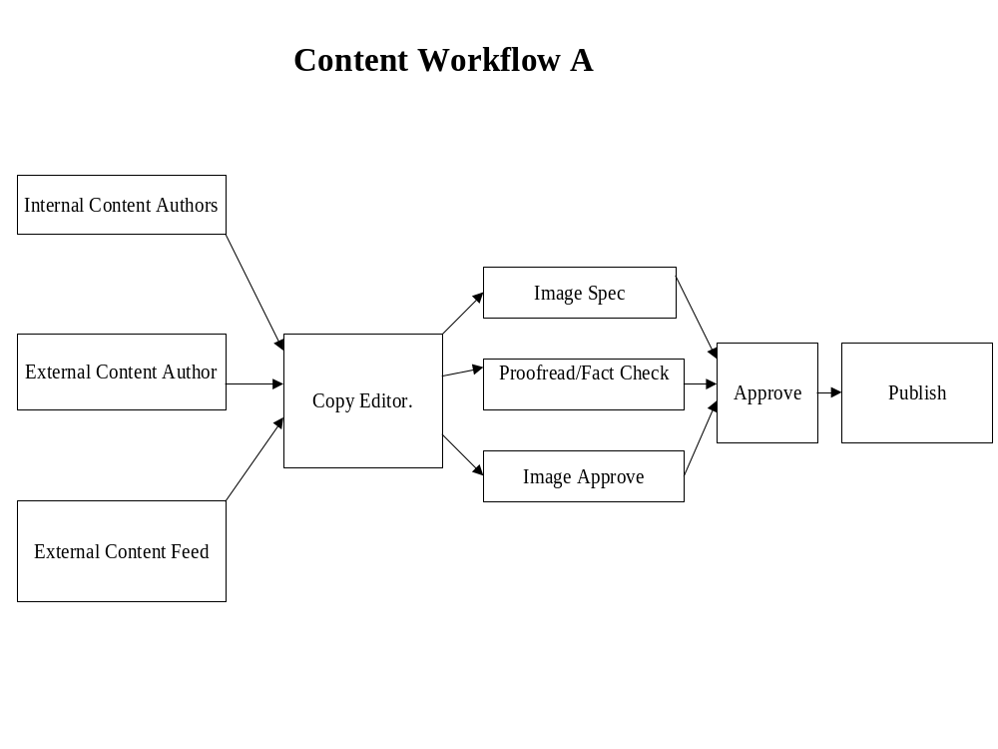

Sample Work Product
Current Workflow Approval Points | Current Approval Types
LOB Manager | Approve no edits, Approve directly to production for certain content types
Other LOB Affected | Approve with/without edits
Legal | Approve with/without edits, Initial creation approval only for certain content types
Compliance | Approve with/without edits, Initial creation approval only for certain content types
Corporate Marketing | Approve with/without edits, Initial creation approval only for certain content types
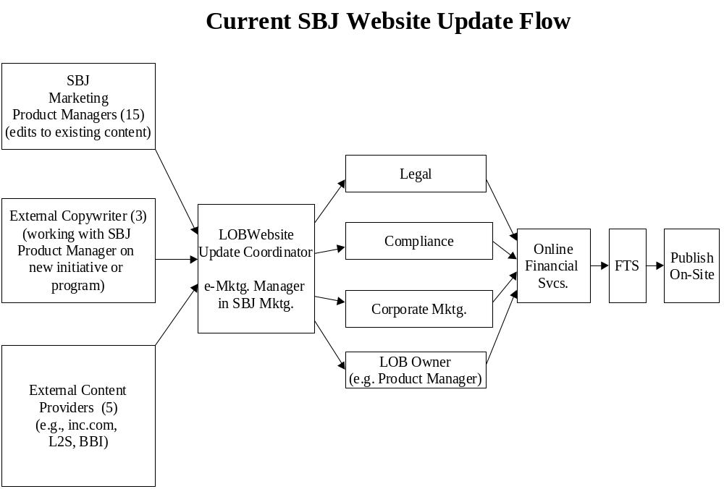

Publishing Requirements

Overview | Publishing requirements provides the information necessary to determine the different mediums to which content will be published from the BroadVision system. The assumption during this exercise is that content in the BroadVision system primarily will be published as browser-compatible content. Some content may be required to support different mediums of delivery such as wireless applications.

Approach | The approach to identifying publishing requirements is to examine and determine which content categories may need to support different mediums of delivery, such as wireless applications. If multiple mediums are determined as necessary, then the effort required to fulfill this requirement will be identified as well. Generally, the addition of content attributes can be used to support this need for multiple mediums.

Work Product | The typical working document is a reworked user content needs matrix identifying any content items that must support different mediums of delivery. This document is prepared and managed in an MS Excel worksheet in a matrix form that provides for ease of manageability and organization. The typical column header which identifies this information is labeled publishing requirements. In many cases, if no additional mediums are supported, then no work product is created.

Input | Completed user content needs and client personnel who are familiar with existing content and site personalization strategy.

.

Work Product Template
Content Need ID | Content Topic | Description | Approx. Number of Items Needed | Expected Source | Expected Owner | Content Type (Static Files, Dynamic DB/ Personalized, Application) | Exist Today? / Existing Content XREF | Publishing Requirements
1 | Articles
 |  | Case studies |  |  |  |  |  | Web
 |  | Feature stories |  |  |  |  |  | Web, WAP

Sample Work Product
Categorization XREF | Content Need ID | Content Group Needed | Example Content Pieces/Descriptions | Expected Source | Expected Owner | Content Type (Static Files, Dynamic DB/ Personalized, Application) | Publishing Requirements (Web, Wireless, Other)
4.1 | 1 | Small Business Articles |  |  | BBI, L2S, Inc.co |  |  |  | Web
 |  |  | Static/Evergreen content. Collection of articles of interest to small business owners. Each article will be written using the language and format to which small business owners respond. Sample topics include: |  |  |  |  | Static Files | Web/Print
 |  |  | Creating a company-wide collections program |  |  |  | Static Files | Web/Print
 |  |  | How Credit Reports Are Evaluated: A Banker’s Perspective |  |  |  |  | Static Files | Web/Print
 |  |  | How to Build an Online Customer Mailing List |  |  |  | Static Files | Web/Print
 |  |  | Creating an Effective Email Newsletter |  |  | Static Files | Web/Print
 |  |  | Five Tips For Starting a Professional Practice |  |  |  | Static Files | Web/Print
 |  |  | Using the Web to Keep Up with Industry News and Developments |  |  |  |  | Static Files | Web/Print
 |  |  | How to Put Together a Compelling Employment Offer |  |  |  | Static Files | Web/Print
 |  |  | Preparing a Business For Sale |  |  | Static Files | Web/Print
 |  |  | Answers to Common Business Valuation Questions |  |  |  | Static Files | Web/Print
 |  |  | Five Ways to Broaden Your Customer Base |  |  |  | Static Files | Web/Print
 |  |  | Vertical articles (women, Platinum) |  |  | Static Files | Web/Print
 |  |  | How to Manage Available Cash |  |  | Static Files | Web/Print
 |  |  | Technology |  |  | Static Files | Web/Print
 |  |  | HR issues |  |  | Static Files | Web/Print
 |  |  | Business Lifecycle (at what stage is my business?) |  |  |  | Static Files | Web/Print
 |  |  | Preparing to Sell Your Business |  |  | Static Files | Web/Print
 |  |  | Startups |  |  | Static Files | Web/Print
4.1 | 2 | Case Studies |  | BBI |  |  | Web/Print
 |  |  | Static/Evergreen content. Case studies will focus on Bank customers’ real-world experiences. Companies profiled will be selected based on Bank’s SBS segment marketing focus. Current segments include: women-owned businesses, professional services, and Platinum. Influencer groups include CPAs. The format for the case study will be “Lessons Learned.” Case studies will be archived based on lesson topic. |  |  |  |  | Static Files | Web
 |  |  | SBS recognition section ("Hall of Fame") |  |  | Static Files | Web
1 | 3 | News |  | Portal |  |  | Web
 |  |  | Dynamic/Timely Information. A set of headlines of local, national, or global news that the customer could personalize. Customer can personalize access to headlines as noted below: |  |  |  |  | Dynamic Feed Based | Web
1.1 |  |  | National and international headlines |  |  | Dynamic Feed Based | Web
1.3 |  |  | Local headlines |  |  | Dynamic Feed Based/Personalized | Web
1.4 |  |  | Small business oriented headlines (I.e. MSNBC small business headlines -- we have these on Bank.com today) |  |  |  |  | Dynamic Feed Based/Personalized | Web
 |  |  | Headlines on specified companies (I.e. I want to see all headlines related to IBM, Fidelity and Bank) |  |  |  |  | Dynamic Feed Based/Personalized | Web
1.5 |  |  | Specified interest/industry oriented headlines (I.e. women owned businesses, CPAs, startups, legal/medical, news related to specified industry associations, etc.) |  |  |  |  | Dynamic Feed Based/Personalized | Web
1.10 |  |  | Consider options such as offering Dow Jones and Wall Street Journal updates to Platinum only as these are more expensive feeds |  |  |  |  | Dynamic Feed Based/Personalized | Web
DUPLICATE |  |  | BPS-related news? |  |  | Static Files | Web
1.6 | 4 | Weather | Dynamic/Timely Content. Access to weather across the country. Customer should be able to select “default” weather display (i.e. the weather in their business location). Weather should be updated frequently throughout the day. | Portal |  | Dynamic/Timely Content/Personalized | Web
1.8 | 5 | Stocks | Dynamic/Timely Content. Access to real-time stock information | Portal |  | Dynamic/Timely Content | Web
1.9 | 6 | Currency Exchange Rates | Dynamic/Timely Content. Feed of updated currency exchange rates for customers doing business overseas. Rates should be the same as those on the Bank Foreign Exchange area. This requirement could make this an Application instead. | Portal |  | Dynamic/Timely Content | Web
1.7 | 7 | Travel Information | Dynamic/Timely Content. Access to business travel information such as: | Portal |  | Dynamic/Timely Content | Web
1.7.1 |  |  | Best air fares |  |  | Dynamic/Timely Content | Web
1.7.2 |  |  | Best hotel fares |  |  | Dynamic/Timely Content | Web
1.7.3 |  |  | Ability to book travel arrangements (air, hotel, rental car) |  |  |  |  | N/A | Web
 |  |  | Mapping application for car travel |  |  |  | Web
7 | 8 | Small Business Tips | Dynamic/Timely Content. Weekly tips focusing on how to avoid common small business mistakes and face business challenges. Length of each tip will be approximately 35 to 75 words. Tips should pop up when customer visits site. Need to utilize portal personalization engine to insure that same tip isn’t popped up again if customer visits again prior to weekly tip refresh. Six months worth of tips (26) will be archived on the server, to be refreshed weekly. | BBI |  | Dynamic/Timely Content/Personal Portion | Web
 |  |  | Categorize by segment or vertical segment |  |  |  | Web
 |  |  | If Only Someone Told Me -- weekly tips focusing on how to avoid common small business mistakes and face business challenges. 35-75 words. |  |  |  |  |  |  | Web
5.3, 5.4 | 9 | Small Business Pulse | Dynamic/Timely Content. A database of small business statistics that is continually showcased on the small business home page. Data will be presented with a “why this information matters to your business” angle to make it meaningful to all site visitors. Data will be updated monthly. Previous months stats (at least the past year) should be archived on the server and should be accessible to customers (i.e. “click here to see previous statistics) . | BBI |  | Dynamic/Timely Content | Web
6.2 | 10 | Information on Bank SBS checking/saving account rates | Dynamic/Timely Content. Rates on Bank SBS checking and savings products. Customer should be requested to select state prior to receiving rate information. Database should be updated as rates change (is this weekly?). | Internal database |  |  | Dynamic/Timely Content | Web
6.3 | 11 | Equity Calculator | Interactive. A calculator that would help a user determine the value of an equity based on current pricing and amount owned. |  |  |  |  | N/A | Web
6.4 | 12 | Loan Need Calculator | Interactive. Tool that enables businesses to determine how much money they should request when applying for a bank loan. This calculator can be linked to the Business Plan Tool. |  |  |  |  | N/A | Web
6.5 | 13 | Loan vs. Lease Calculator | Interactive. Tool that helps businesses to determine the cost of borrowing “to own” vs. leasing. Should be business oriented (or at least more generic than “use this tool to see if you should buy or lease your car!) |  |  |  |  | N/A | Web
6.6 | 14 | Loan Payment Calculator | Interactive. Tool that enables businesses to enter a loan amount, interest rate and payment period, and receive loan payment figure. |  |  |  |  | N/A | Web
6.7 | 15 | Salary Calculator | Interactive. Tool that enables a small business owner to enter their geographic location, industry/job type and salary level, and receive back comparative information on how their compensation stacks up locally and industry-wide. Also helpful for identifying average salaries in different industries (if customer is interested in a career/industry change). For example, check out the “Paycheck Check-up Tool” on womenconnect.com. URL to link to it is:http://www.womenconnect.com/Loclink/JOBC/TRANSITION/TOOLS |  |  |  |  | N/A | Web
6.8 | 16 | Relocation Tool | Interactive. Tool that would allow a small business owner to enter city and state that they may relocate to, and be fed back information on housing costs, quality of schools, crime rate, etc. |  |  |  |  | N/A | Web
6.9 | 17 | StartUp Business Tools |  |  |  |  | N/A | Web
 |  |  | Interactive. Tools to help an entrepreneur understand what they need to get a business started. Examples of tools include: |  |  |  |  | N/A | Web
6.9.1 |  |  | New Business Cash Needs Estimate Worksheet (to compute the amount of startup cash you need) |  |  |  |  | N/A | Web
6.9.2 |  |  | Identify Start-Up Expenses (understanding what it will cost to start up your business) |  |  |  |  | N/A | Web
6.9.3 |  |  | Identify Operating Expenses (anticipate what it will cost to operate each month) |  |  |  |  | N/A | Web
 |  |  | Additional examples can be found at: www.news.onvia.com/tools_finance.xml |  |  |  |  | N/A | Web
6.10 | 18 | Retirement Plan Calculator | Interactive. An interactive tool that enables businesses to calculate best retirement plan option for themselves and their employees. Calculator should include a comparison of funds saved in retirement plan vs. tax savings. |  |  |  |  | N/A | Web

Organizational Readiness Work Product Flow
Define organizational structure
Define training needs based upon skill gaps
Define organization needs based upon gaps
Define current skills

Current Organizational Structure

Overview | A new web technology will normally have an impact on the structure of the organization. As process changes are defined for maintaining dynamic personalized content, new roles and responsibilities are identified, information on the impact to the organization structure must be gathered. An assessment of the current structure must occur.

Approach | The approach to identifying the current structure requires three steps. First, locate and collect all current organizational charts. Next, identify and define all reporting relationships within the organization. Finally, define completely all job descriptions within the organization.

Work Product | The typical working document will be an organization chart indicating the relationships between divisions, units, groups, and/or individuals. This document is prepared and managed in either of the following: MS Excel worksheet, MS PowerPoint, or Visio. Also, textual information describing the relationships between various units can either appear on this chart or when extensive detail is available in an MS Excel or MS Word document. In the case of extensive detail, typical column headers that identify the information include entity x, entity y, relationship type, and relationship description. Finally, all job descriptions can be prepared and managed in MS Word or MS Excel. Typical column headers that identify the information are job title, tasks, output, tools required, skills required, performance measures, etc.

Input | Organization charts and information provided by personnel familiar with the organizational structure.

See following pages for organization charts, job relationship matrix, and job description table.

Work Product Template
TBD

Sample Work Product
TBD

Current Organizational Skills

Overview | After documenting the organizational structure, it is necessary to define the current skills within the organization. This task identifies whether or not the existing skill sets support current operations, the existing skills support the change process and the new technology, and the type of organizations or procedures in place to support the development and delivery of training.

Approach | The approach to identifying the current skills requires gathering information about the skill sets possessed by each business unit or key constituent, corroboration is required. This is typically accomplished by completing the skills inventory form for a particular unit and then having that unit's direct supervisor complete one for the unit as well.

Work Product | The typical working document will be a skills inventory form that can be managed in MS Word or MS Excel. Typical column headers that identify the information are job title, task title, required skills, etc.

Input | Sources of information can include the following: job descriptions, written policies and procedures, information systems user manuals, business unit leaders, senior management, personnel department, recruiting manager, organization charts, work plans, and previous or concurrent activities such as organizational and  process mapping.

See following page for skills inventory form.

Work Product Template
TBD

Sample Work Product
TBD

Organizational Readiness Training Needs

Overview | Once an overall picture of the organization and its skills sets is developed, the training function can be assessed. By reviewing the typical skills sets required for the new web site and comparing it to the existing skills base, a gap analysis is completed defining what training may need to occur immediately, and what training may occur in later phases of the project.

Approach | The approach to identifying the training needs requires assessing the current training function. Create an inventory of the all current training practices. Document training needs for short and long term. Identify the training necessary to deliver the skills to fulfill desired needs for web implementation, i.e., personalizing custom experience requires BroadVision and Javascript training.

Work Product | The typical working document will be an inventory form to collect information on the current training. Typical column headers that identify the information are training type/name, internal/external, formal/informal, credits/hours, certification, and description of training and skills developed. Another form will provide a summary of training needs with typical column headers for requirements and priority. These documents can be prepared in either MS Word or MS excel.

Input | Sources of information can include the following: job descriptions, training manuals, course offerings and description, training programs (internal/external), business unit leaders, senior management, and personnel department.

See following pages for training inventory, training requirements for short term, and training requirements for long term.

Work Product Template
TBD

Sample Work Product
TBD

Organization Needs

Overview | A gap analysis can typically be completed at this point by comparing typical web functional units to the existing organizational structure. The purpose of this step is to assess the organization in order to determine the changes needed to enable successful implementation of the new technology and to define a practical listing of opportunities for improvement.

Approach | The approach to identifying the organization needs requires the organization team to document what the organization needs to do. The team would conduct brainstorming sessions to generate ideas regarding desired needs at a high level, i.e., setup content assessment, quality assessment, business rule creation/modification, etc.

Work Product | The typical working document will be an MS Excel spreadsheet that can be used to document ideas generated from a brainstorming session with typical column headers that include, idea, idea description, pros, cons, priority, resources required, and comments.

Input | Organization charts and information provided by personnel familiar with the organizational structure. Input from personnel most familiar with web-related initiatives, i.e., business content, maintenance, and business rules are invaluable resources.

See following page brainstorming idea chart.

Work Product Template
TBD

Sample Work Product
TBD

Technology Work Product Flow
Define Technical Infrastructure

Define Technical Architecture

Define Reporting Requirements

Define Search Requirements

Define Data Architecture

Define Interface/Batch/Data Migration Architecture

Technical Architecture Overview
Review business objectives and priorities document
Review BroadVision "out of the box" functionality
Determine technical architecture limitations within release timeframes
Create release functionality matrix (response to business objectives and priorities document)

Review Business Objectives and Priorities Document
Overview | The purpose of this step is to gather those business objectives that directly deal with technology architecture side of the project. Business objectives are broad statements of direction indicating what the project aims to achieve. An example of a business objective is "Improve the overall system performance."

Approach | Definition team members will review the objectives and priorities document and focus on those areas that specify directions for technical architecture development. This task should allow the definition team to narrow their scope and outline the priorities.

Work Product | The business objectives and priorities document should have been created in prior definition stages. No changes are required to it at this point

Review BroadVision "Out of the Box" Functionality
Overview | The purpose of this step is to compile information on functionality of IT Architecture components that are provided with standard installation of BroadVision software.

Approach | Definition team should refer to BroadVision Installation and System Administration Guide for version 5.5. This document clearly outlines the type of IT environment required for BV operations.  The following Server configurations suited for BroadVision systems are shown from Figure 1-0 through Figure 1-6.

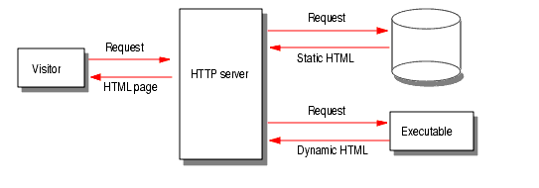

Fig 1-0: Server operation

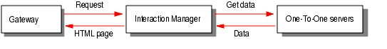

Fig 1-1: Gateway between requestor and data

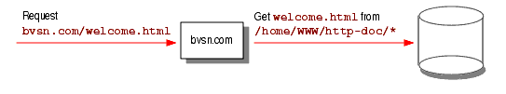

Fig 1-2: Redirection to document root



Fig 1-3: Interaction between One-To-One and HTTP servers

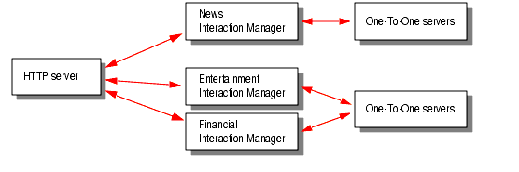

Fig 1-4: Operation of multiple interaction managers

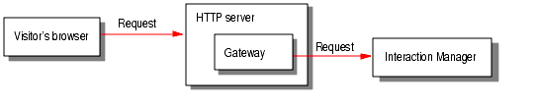
Fig 1-5: Interaction with Gateway application

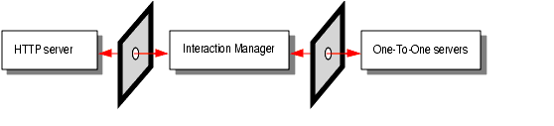

Fig 1-6: Firewall set-up

Determine Technical Architecture Limitations within Release Timeframes
Overview | The purpose of this task is to identify key constraints in defining the IT architecture alternatives. Examples of these factors include:  Required use of specific vendors/products  Required use of legacy system components  Application software package constraints  Required remote user support  Required interfaces  Required technology standards  These limitations are gathered based on application/infrastructure needs and/or cost/benefit analysis.

Approach | The following process and performance requirements have been identified:  Physical Design Assumptions  - The Intranet portal will be physically separate from the Internet portals  - Geographic load balancing for the Internet and Intranet solutions is needed for uptime, fail over, and performance  - Internet servers will be housed in Albany and Waltham on “eNable” framework for LAN connectivity currently in build out for CIB/Homelink. Waltham site considered DR site for Internet.  - Intranet servers will be housed in Albany and Waltham.  - DR sites will have full 100% capabilities if DR occurs.  BroadVision Application Assumptions  - Ratio 4:1 IM to web  - Ration 3:1 IM to CNTDB  - Ration 5:1 IM to BroadVision Database  - 1 GB Ram per CPU  - 2 IM per CPU  - 200 concurrent sessions per IM → Gives 1600 concurrent sessions per 4 CPUs  - 2 minutes page turn rate  - For version 0.1 Intranet, Pages/CPU/Second will be 20  - For version 1.0, 2.0 Intranet, Pages/CPU/Second will be 10  - For version 1.0 Internet, Pages/CPU/Second will be 10  - For version 2.0 Internet, Pages/CPU/Second will be 10  - As more powerful CPUs are used and once application tuning occurs, the Pages/CPU/Second may increase and reduce the amount of hardware needed for production.  Bandwidth Assumptions  - 50 KB per web page  - .5 pages per minute  - 4 transactions per page  - 5 KB per transaction  - Existing ISP vendors will be used for Internet connectivity  Database Assumptions  - BroadVision base schema is 170 tables divided into three sections:  - User profile – moderate reads, low writes  - Content – very little write, little read, heavily cached  - Transaction – heavy read and write – 3KB-5KB per transaction  - Out of box install is 135 MB including metadata  - Assume 5 GB data per portal through v 2.0  - User Profile and Transaction sizes are 3KB-5KB  - Content data should be pointers to files on file system  - Observation database for analytical manipulation is needed. Approximately 400 MB in size for every 1MM hits/day.  - Minimal database access once a steady state is achieved. High amount of caching at the Interaction Manager layer.  - Large DB implementations use Sun E450, 4GB RAM, 4 CPUs

Create Release Functionality Matrix
Overview | Release functionality matrix is the definition document that outlines the functionality and capabilities of the system that is being designed.

Approach | Design would be responsible for coming up with the release functionality matrix. Such a document should outline the major areas of system functionality along with what priorities suit them.

Work Product | The Release Functionality Matrix is a document that highlights major features of a system that is being designed. This document also indicates requirements for the features, along with the features priority.

Sample Release Functionality Matrix | A sample of Release Functionality Matrix is attached below:

Interface/Batch/Data Migration Architecture Overview
Review back-end systems
Define data mapping between BroadVision and each back-end system

Define interface requirements between BroadVision and each back-end system

Review Back-End Systems
Overview | During this activity, the various backend systems are analyzed for potential integration with BroadVision. While integration may not happen with the first release of the application, it is important to perform this analysis and identify potential requirements regardless of timing of roll-out.

Approach | - Develop Management Overview Diagram identifying potential inputs and outputs with BroadVision application.  - Identify existing back-end and legacy systems and their functionality and/or data content  - Identify requirement for timing of integration with BroadVision application

Work Product | An MS Word table depicting back-end systems, their function and the kind of data they store is produced.

Sample Worksheet

Sl No. | System | Data Content | Platform | Potential Interface? | Priority
1 | CMS | Card Management System | NT - Oracle | Yes – Customer Data required for end-user personalization | High
2 | HOGAN | Customer information, Product information
3 | AFS | Commercial loans
4 | ACLS | Retail, small businesses, Personal Loans

Define Interface Requirements between BroadVision and Back-End Systems
Overview | The purpose of this task is to identify the scope and requirements for interfacing data with the BroadVision application. A comprehensive understanding of integration between legacy systems and BroadVision is required to determine the issues, options and approaches for the various interfaces. The objective of this task is to provide direction as well as a central source of information for the ensuing interface tasks. Additionally, this assessment should include a review of the necessity of middleware applications for performing integration.

Approach | - Review the Back-end Systems deliverable and identify detailed interface requirements. (In addition to an Interface Overview Diagram, the detailed interface requirements should include high-level process overview, any associated issues and certain key assumptions made around the interface and/or assessment deliverable.)  - Determine if a middleware application is required for integration or if a custom component can be developed to perform integration

Work Product | A comprehensive Interface Assessment is produced in MS Word. An Interface Overview Diagram is produced in MS Powerpoint to identify the interfaces and their associated applications. Additionally, if required an analysis of various middleware applications is produced in MS Word format identifying the reason for and requirements of the middleware.

Sample Worksheets

Detailed Interface Requirements List

# | Name/Description | Back-End System | Platform | In/Out | Frequency | Volume | Priority | Effort Level
1 | Customer Data - data required for end-user personalization | CMS | NT - Oracle | In | 10/day | # lines | H | M

Table of Contents for Interface Assessment Deliverable

- Introduction
  - Document Objectives
  - Interface Objectives
  - Assumptions
  - Issues

- Systems Interface Overview
  - Interface Overview Diagram
  - Interface Process Descriptions

Define Data Mapping between BroadVision and Back-End Systems
Overview | The purpose of this activity is to map the data elements that must be interfaced between the external legacy systems and the BroadVision database tables.

Approach | - Define the external legacy system data elements to be presented on the site  - Determine data fields from the BroadVision tables that will hold the data  - Establish a mapping between the two systems

Work Product | A typical work product is an MS Excel document for each identified interface, mapping its data element to BroadVision’s database fields. The spreadsheet is “split” for the legacy and BroadVision applications and typical column headers include:  - Data Element (Field) Name  - Table Name  - Format (Character, Number, Alphanumeric)  - Position Start  - Position End  - Length  - Field Default  - Description

Technical Infrastructure Overview
Order required Hardware
Define configuration management
Review 'as-is' technical infrastructure
Determine technical infrastructure requirements
Define environment strategy (including staging)
Define 'to-be' technical infrastructure
Define technical conventions and standards (naming conventions, standard directory structure, coding standards)

Review ‘as-is’ Technical Infrastructure
Overview | The purpose of this task to review the existing technical infrastructure. Such knowledge should give the definition team an understanding of what needs to be done to modify the system to required level.

Approach | The definition team would analyze provided documentation in order to gain an understanding of existing IT Infrastructure Environment. They should gain a comfortable level of understanding of current systems and procedures, so that they would be able to come up with accurate requirements in future steps.

Work Product | No work product is required for this stage. However, the definition team members may wish to compile their notes in order to be used for reference in future planing and design.

Determine Technical Infrastructure Requirements
Overview | The purpose of this task is to determine the high-level IT infrastructure requirements that will drive the design of the IT infrastructure. These requirements may be defined in terms of specific processing or performance requirements, or specific connectivity or compliance with corporate policies (e.g., security).

Approach | The following IT infrastructure requirements have been identified:  Physical Design Requirements  - The Intranet portal will be physically separate from the Internet portals  - Geographic load balancing for the Internet and Intranet solutions is needed for uptime, fail over, and performance  - Internet servers will be housed in Albany and Waltham on “eNable” framework for LAN connectivity currently in build out for CIB/Homelink. Waltham site considered DR site for Internet.  - Intranet servers will be house in Albany and Waltham.  - DR sites will have full 100% capabilities if DR occurs.  BroadVision Application Requirements  - Ratio 4:1 IM to web  - Ration 3:1 IM to CNTDB  - Ration 5:1 IM to BroadVision Database  - 1 GB Ram per CPU  - 2 IM per CPU  - 200 concurrent sessions per IM → Gives 1600 concurrent sessions per 4 CPUs  - 2 minutes page turn rate  - For version 0.1 Intranet, Pages/CPU/Second will be 20  - For version 1.0, 2.0 Intranet, Pages/CPU/Second will be 10  - For version 1.0 Internet, Pages/CPU/Second will be 10  - For version 2.0 Internet, Pages/CPU/Second will be 10  - As more powerful CPUs are used and once application tuning occurs, the Pages/CPU/Second may increase and reduce the amount of hardware needed for production.  Bandwidth Requirements  - 50 KB per web page  - .5 pages per minute  - 4 transactions per page  - 5 KB per transaction  - Existing ISP vendors will be used for Internet connectivity  Database Requirements  - BroadVision base schema is 170 tables divided into three sections:  - User profile – moderate reads, low writes  - Content – very little write, little read, heavily cached  - Transaction – heavy read and write – 3KB-5KB per transaction  - Out of box install is 135 MB including metadata  - Assume 5 GB data per portal through v 2.0  - User Profile and Transaction sizes are 3KB-5KB  - Content data should be pointers to files on file system  - Observation database for analytical manipulation is needed. Approximately 400 MB in size for every 1MM hits/day.  - Minimal database access once

Define Environment Strategy (Including Staging)
Overview | The purpose of this task is to define all of the production and non-production environments required to satisfy the project and business requirements.

Approach | To complete the scope definition, it is necessary to identify all of the required environments for the project. Proper identification of the number of required environments is essential in planning the level of effort, number of resources, and cost of the development efforts and the cost of the IT infrastructure.  The environment strategy is also going to specify chronological stages for installing and configuring required environments.

Work Product | Definition team will prepare a preliminary IT environment strategy document to include the following items:  - Identification of the required environments  - Preliminary implementation and support strategies  - Preliminary cost estimates  The team will then discuss document with management and make changes as necessary.

Sample Environment Strategy Document | A sample Environment Strategy Template is attached below:

Define Configuration Management (Version Control, Build Procedures)
Overview | Configuration Management is a collection of techniques that will ensure that the evolution of system components is efficient and controlled. It is a series of tools, standards and procedures that coordinates application development, quality assurance, application testing, application promotion, and methods.  Configuration Management is an integral part of the development process and will provide a focal point for issue identification and resolution, as well as product and project status.

Approach | Definition team will write a configuration management document to address the following issues:  1. Configuration control  - Configuration Identification  - Configuration Change Control  - Version Control  2. Release Management  3. Platform Configuration  4. Configuration Auditing  5. Repository Management  6. Software promotional life cycle

Work Product | The configuration management document would include specifications for all of the aspects of configuration management. The specific details would be placed in appropriate tables and provide appropriate configuration items, descriptions, and version numbers.

Define Technical Conventions and Standards (Naming Conventions, Standard Directory Structure, Coding Standards)
Overview | The purpose of this task is to define the technical conventions and standards in accordance with established BroadVision Practices.

Approach | The definition team is going to come up with Development Guidelines and Standards in order to specify proper development practices. These guidelines will specify proper notation and naming conventions for IT Environment Infrastructure Components.

Work Product | Development Guidelines and Standards provide clear and precise in instructions on technical conventions and standards that are to be followed by design and development teams.

Sample Development Guidelines and Standards | A sample of Development Guidelines and Standards is attached below:

Define ‘to-be’ Technical Infrastructure
Overview | The purpose of this task is to assemble a document, outlining the infrastructure design to serve as a basis for subsequent project planning, product selection and detailed IT infrastructure design efforts.

Approach | The infrastructure architecture definition process concludes with the assembly of a document describing the decisions made to date, the rationale for those decisions, the open issues, and the updated cost estimates for the infrastructure. This document communicates the "big picture" infrastructure design for use by the infrastructure team, software developers, and support personnel. It also provides a basis for implementation planning activities, identifying remaining open issues, completing remaining product evaluations, and specifying architecture components to be implemented.  While details of the infrastructure will be refined over time, the major decisions documented in the IT Infrastructure Abstract should represent the infrastructure design as agreed. It should summarize the following information, assembled to date through the architecture definition process:  - High-level infrastructure requirements  - Summary of current infrastructure shortfalls  - Proposed infrastructure design, discussing how the design satisfies requirements, including:  - Network approach  - Database approach  - Server and client strategy  - Outsourcing strategy  - Management tools  - Support and management approach  - Expansion, redundancy, and recoverability approach  - Open issues and future options  - Implementation milestones  - Updated cost estimates

Work Product | IT Infrastructure Abstract document, including the following sections:  - Environment Approach  - ITI Selection Results  - Schematics  - Product Placeholders  - Open Issues Documents  - Future Directions  - Refined Infrastructure Costs  - Organizational Considerations  - Appendices  This document should be submitted to management for formal written approval.

Sample IT Infrastructure Abstract | Refer to attached IT Component Infrastructure document for the content, though not necessarily the format, of an IT Infrastructure Abstract

Order Required Hardware
Overview | The purpose of this task is to specify procedures for ordering the required hardware components.

Approach | Definition team’s agreements with hardware vendors provide an advantage in obtaining equipment on site, allowing for more precise integration of hardware and software availability into the project schedules.  Project management should approve the actual purchasing costs and procedures.

Reporting Requirements Definition Overview
Review default BroadVision reports
Validate reporting requirements with business team

Perform gap analysis

Report Design
Overview | This activity entails the review of standard reports provided by BroadVision, BroadBase and E.piphany against the reporting requirements of the site and specification of custom reports, if any.

Approach | BroadVision provides a set of standard reports to track activities such as:  - What percentage of visitors selected a particular advertisement?  - What percentage of visitors have profiles?  - What percentage of visitors clicked an advertisement when it appeared on the bottom of a page, as opposed to the percentage that clicked it when it appeared on top?  These reports help in evaluating the site’s performance and planning for optimal results.

Work Product | A typical work product is the analysis of standard reports offered.

Review Default BroadVision Reports

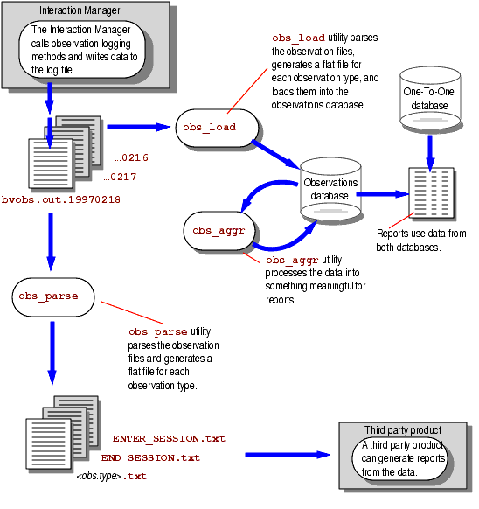

Perform Gap Analysis

Overview | During this activity the Web site’s reporting requirements are analyzed against the capabilities offered by BroadVision, E.piphany and BroadBase.

Approach | - Review the reporting requirements to be implemented in the Web site  - Review standard reports offered by BroadVision  - Review standard reports offered by E.piphany and BroadBase  - Define custom reports, if any

Work Product | The work product is a final set of reports that can be implemented on the site.

Placeholder for Gap Analysis matrix

Validate Reporting Requirements with Business Team

Overview | The Technology and Business teams meet during this task to validate and finalize reporting requirements.

Approach | - Specify reporting requirements that can be implemented on the Web site  - Review standard reports offered by BroadVision  - Review standard reports offered by E.piphany and BroadBase  - Review custom reports, if any

Work Product | The work product is a final set of reports that can be implemented

Search Requirements Definition Overview
Define search strategy

Review/Develop search requirements
Review base Verity search capabilities
Perform gap analysis

Review, Develop Search Requirements

Overview | In order to provide a personalized experience to the site visitor, the Web site must provide a search mechanism whereby the visitor can search for specific keywords throughout the site. During this activity specific search requirements are gathered and defined.

Approach | - Analyze the content to be searched  - Analyze how frequently the content will undergo change  - Analyze the various search mechanisms that can be deployed

Work Product | The work product is an MS word document describing the content types to be searched and returned.

Placeholder for Search Requirements Template

Review Base Verity Search Capabilities

Overview | This activity entails analysis and review of the search capabilities offered by the third party Verity SEARCH 97 product and matching its capabilities with the search requirements of the site.

Approach | - Review the content types to be search  - Determine the static or dynamic nature of the content types to be searched  - Determine the volume of content to be searched  - Review Verity’s indexer utility  - Review Verity’s collections

Work Product | An MS Word document describing the capabilities of Verity SEARCH 97 that would be used for the site is prepared.

Placeholder for Analysis of Search Tools sample deliverable

Perform Gap Analysis

Overview | During this activity the site’s search capability requirements are analyzed against the capabilities offered by the Verity software.

Approach | - Review the search requirements to be implemented in the Web site  - Review search features of Verity SEARCH 97  - Identify the search requirements of the Web site that can be implemented using Verity SEARCH 97

Work Product | The work product is a finalized set of search features that can be implemented using the Verity SEARCH 97 search engine.

Placeholder for Verity Search Capability Gap Analysis

Define Search Strategy

Overview | This activity summarizes the search strategy to be employed – the search utility that will be used to implement the search, the content types that can be searched and their typical volume, and the search features that can be implemented.

Approach | - Determine the search utility that will be used  - Determine the system requirements for the search utility  - List the content types that can be searched using the utility  - List the search features that can be implemented on the site

Work Product | An MS Word document describing the search utility to be employed, its features and the final set of search features that will be offered on the site is produced.

Placeholder for Search Strategy document

Data Architecture Overview
Identify data sizing estimates

Identify Data Sizing Estimates
Overview | A data dictionary, describes what is in the database and contains textual definitions of data elements and objects, as well as physical representation information (e.g., size, precision, ranges, default values, dependencies on other data elements, relationships with other data elements, and frequencies). The relational data typically makes up most of the data to be considered during the data sizing process. Additionally, the data that is stored in flat files or other systems need to be accounted for in order to estimate the total data needed to fulfill a requirement.

Approach | Define each attribute in the data model to its final level. This definition should include location, size, format, edit, and value information.  Other issues to address include:  Data stored in flat files  Data stored in other systems  Conversion requirements for data in a different format
Work Product | In a normal estimation process, a mapping of each data element to a requirement and all other data sources that make up that requirement is stored in the estimation templates.

Input | Define marketing and branding requirements  Define content migration requirements  Define data mapping between BroadVision and back-end system

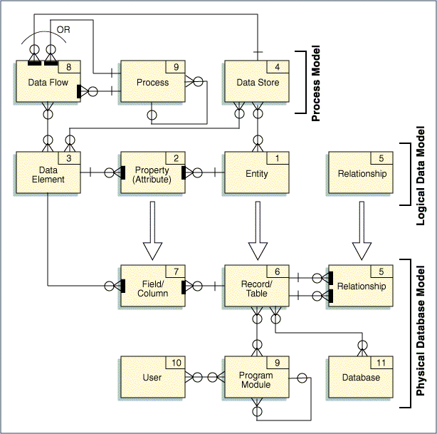

Placeholder for Data Sizing Estimates template

Testing

Glossary

